STUDENT ENROLLMENT & COURSE MANAGEMENT SYSTEM
Naan mudhalavan report
submitted in partial fulfilment of the requirements for the Award of Degree of
BACHELOR OF SCIENCE
in
COMPUTER SCIENCE
Submitted by
Team No:1
Team Leader: Jeevan Kishore S.
Team Members:1. Jayasurya R.
2.Kalaikumar S.
3.Kathiravan G.
4.Kathir K.
Under the Supervision of
Ms. Poovarasi S.

PG and Research Department of Computer Science
Don Bosco College (Co-Ed)
Yelagiri Hills
JUNE-2026
User Story
The Student Enrollment & Course Management System (SECMS) is a Salesforce application created to support the academic activities of a college or educational organization. The system provides a common platform for maintaining student profiles, academic programs, subjects, faculty information, course registrations, enrollment requests, and academic schedules.
Students and staff can use the system according to their assigned roles. The application helps users submit course requests, review available subjects, manage student-course relationships, assign faculty members, and follow the progress of enrollment activities. Salesforce automation can be used to reduce repetitive operations and keep important academic information updated.
INTRODUCTION
1.1 Project Overview
SECMS provides a digital framework for organizing the academic registration process of an educational institution. The application connects student information, program details, course records, faculty assignments, and registration activities so that authorized users can access the required information from a common platform.
The system can maintain details such as student academic profiles, course capacity, course schedules, instructor information, registration dates, and enrollment status. It can also support automated notifications and record updates when important actions take place.
The Salesforce platform provides several tools that can be configured for this application. Custom Objects can store application data, Relationships can connect related records, Flows can perform automated operations, and Validation Rules can ensure that users enter acceptable information. Reports and Dashboards can be used to present academic information in an understandable format. 1.2 Purpose
The purpose of SECMS is to create a structured environment for managing course registration and academic information.
The system focuses on:
- Maintaining complete student academic profiles.
- Organizing programs, subjects, and course details.
- Managing faculty and their assigned subjects.
- Recording student course requests.
- Monitoring available course capacity.
- Reducing repeated manual data entry.
- Providing role-based access to system information.
- Supporting timely communication between users.
- IDEATION PHASE.
PS | I am (Customer) | I’m trying to | But | Because | Which makes me feel
PS-1 | Student | Find subjects that match my academic program | Course information is not always presented in a single location | Registration details are maintained through different channels | Unsure about which course to select
PS-2 | Faculty Member | View my assigned subjects and registered students | Updated information may take time to reach me | Course and faculty records are maintained separately | Difficult to prepare for my classes
PS-3 | Academic Coordinator | Organize courses according to available capacity | Student registration changes are difficult to monitor | Enrollment information is updated manually | Concerned about incorrect course allocation
PS-4 | Department Staff | Maintain student registration records | Entering the same information repeatedly consumes time | There is no single workflow for registration activities | Tired of repetitive administrative work
PS-5 | Student | Know whether my course request has been processed | Status updates are not always immediately visible | Registration activities require several manual steps | Uncertain about my enrollment status
PS-6 | Faculty Coordinator | Distribute students among available courses | Current registration numbers are difficult to obtain quickly | Information is stored in separate records | Delayed when organizing academic activities
PS-7 | System Administrator | Maintain consistent academic information | Users may enter different or incomplete values | There are limited automated data checks | Concerned about record accuracy
PS-8 | College Management | Understand registration patterns across departments | Preparing consolidated information takes additional effort | Academic information is not available through a unified | Difficult to monitor institutional activities

2.2.Empathy Map Canvas
User Persona: Academic Coordinator
Think & Feel
- Wants the registration process to be organized and easy to monitor.
- Needs reliable information before allocating students to courses.
- Wants to reduce unnecessary follow-up work.
- Feels responsible for maintaining smooth academic coordination.
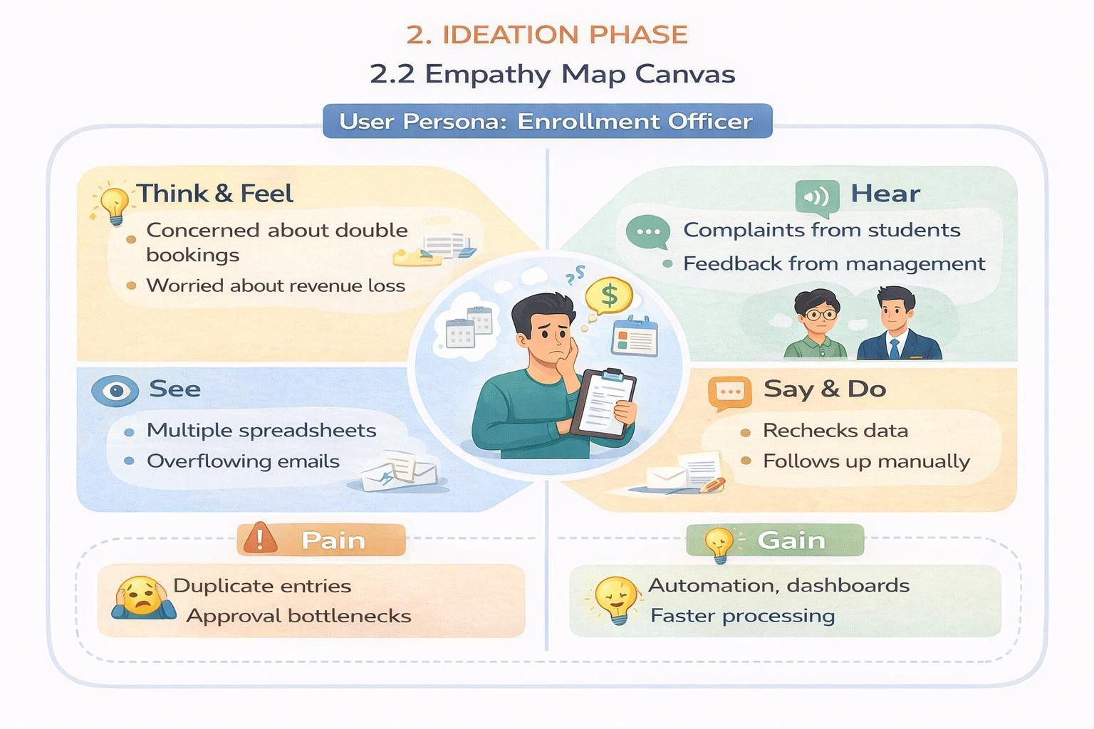
Hear
    - Students asking about course availability.
    - Faculty requesting updated student lists.
    - Department staff asking about registration status.
    - Management requesting enrollment summaries.

See
    - Student registration requests.
    - Faculty allocation records.
    - Pending registration activities.
    - Academic schedules and department information.

Say & Do
- Reviews course availability.
- Checks student registration details.
- Coordinates with faculty members.
- Updates academic records.
- Follows up on incomplete registration requests.
Pain
    - Difficulty identifying the latest registration information.
    - Repeated requests for student and course details.
    - Delays caused by incomplete records.
    - Difficulty tracking multiple registration activities.
Gain
    - Centralized academic information.
    - Faster access to registration records.
    - Automated status updates.
    - Easier course allocation.
    - Clear academic reports.
Brainstorming & Idea Prioritization
Step 1 – Brainstormed Ideas
    - Digital course catalog.
    - Student self-registration module.
    - Faculty allocation tracker.
    - Centralized academic database.
    - Automated registration workflow.
    - Salesforce-based enrollment application.

Step 2 – Grouping
Student-Focused Ideas
Course search.
Course information display.
Registration request submission.
Staff-Focused Ideas
    - Student record management.
    - Course capacity monitoring.
    - Faculty allocation.
Automation-Focused Ideas
    - Automatic status updates.
    - Registration notifications.
    - Record validation.
    - Workflow-based processing.
Step 3 – Prioritization
The ideas were evaluated according to implementation effort, usefulness, scalability, and suitability for the institution.

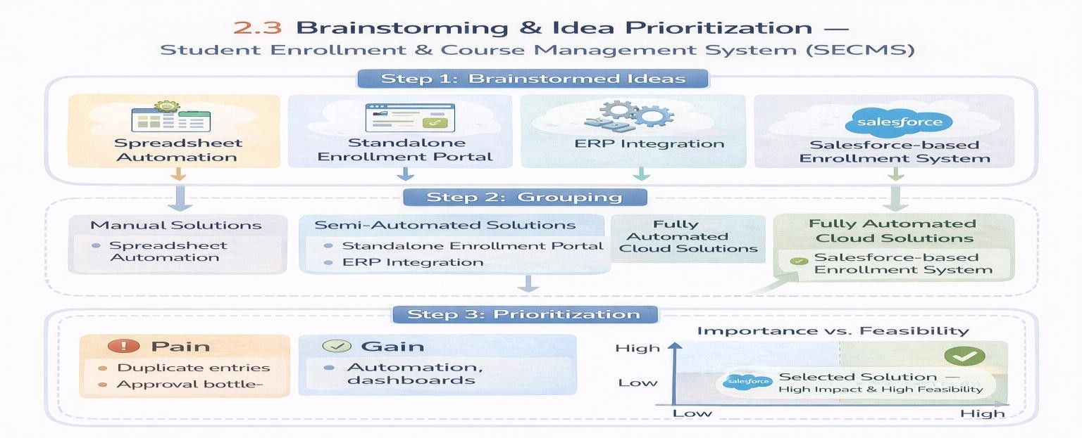
The proposed SECMS solution focuses on combining student registration, course management, faculty allocation, automation, and reporting within Salesforce. This approach provides a structured foundation that can be expanded with additional academic features in the future.
- REQUIREMENT ANALYSIS PHASE
3.1 Customer Journey Map
Stage 1 – Student Profile Creation
The student information is entered into the system and an academic profile is created. Basic details and program information are maintained for future registration activities.
Stage 2 – Course Discovery
The student or authorized staff member reviews the available courses. Information such as course name, department, available seats, schedule, and other relevant details can be viewed.
Stage 3 – Course Request
The student selects the required course and submits a registration request through the system.
Stage 4 – Eligibility & Availability Check
The system checks the submitted information against predefined requirements and verifies whether the selected course has available capacity.
Stage 5 – Registration Processing
The enrollment staff reviews the request and updates the registration record. Required corrections can be handled before the request proceeds further.
Stage 6 – Faculty Allocation
After registration is processed, the appropriate faculty member can be associated with the course based on the institution's allocation process.
Stage 7 – Confirmation & Monitoring
The final registration status is recorded in the system. Students and authorized staff can monitor the progress of the request and access updated information.
Stage 8 – Academic Reporting
The collected information can be used to generate reports related to student registrations, course participation, faculty allocation, and departmental activities.

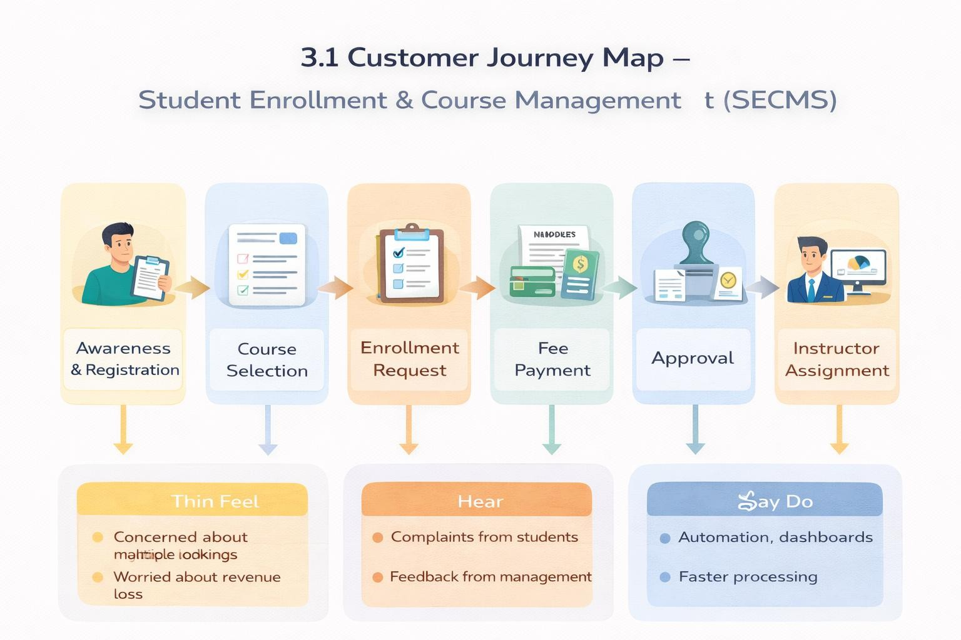
3.2 Solution Requirements
Functional Requirements
FR No | Epic | Description
FR-1 | User Profile  Management | Create, update, and maintain user information based on their role
FR-2 | Program Management | Maintain academic programs, departments, subjects, and related information
FR-3 | Course Registration | Allow students to select available subjects and submit registration requests
FR-4 | Faculty Coordination | Maintain faculty details and associate faculty members with appropriate subjects
FR-5 | Registration Tracking | Monitor the current status of submitted course registration requests
FR-6 | Fee Information | Record course fee details and maintain payment-related information
FR-7 | Notification  Management | Send updates to users when important registration activities occur
FR-8 | Academic Monitoring | Provide summarized information about students, courses, and registrations

Non-Functional Requirements
NFR-1: Accessibility
The application shall provide easily accessible features for different categories of users. Frequently required information should be available through simple navigation and clearly organized pages.
Examples:
- Easy access to student information
- Clearly arranged course details
- Simple registration navigation
NFR-2: Data Integrity
The system shall maintain consistent and valid academic information. Records should follow predefined rules to reduce incorrect or incomplete entries.
Examples:
- Required student information must be completed
- Invalid course details should not be accepted
- Registration records should contain valid course references
NFR-3: Maintainability
The application shall be designed so that administrators can update academic information and modify configured processes when institutional requirements change.
Examples:
- Update course information when required
- Modify registration rules
- Add new academic fields
NFR-4: Responsiveness
The system shall respond efficiently to normal user activities such as searching records, opening course information, submitting requests, and viewing registration details.
Examples:
- Smooth record searching
- Quick opening of student profiles
- Efficient request submission

NFR-5: Flexibility
The application shall accommodate changes in academic structure, including new courses, departments, faculty members, and registration requirements.
Examples:
- Introduce additional subjects
- Create new academic programs
- Modify course capacity
NFR-6: Auditability
Important changes and registration activities should be traceable so that authorized users can understand the progress and history of records.
Examples:
- Track registration status changes
- Monitor record modifications
- Review approval activities

3.3 Data Flow Diagram
The SECMS data flow begins when a student or staff member enters the required information into the application.
- Student information is submitted through the system.
- Course and program information is retrieved from Salesforce records.
- Registration details are created and associated with the relevant student and course.
- Business rules check the submitted information.
- Valid requests are forwarded for further processing.
- Faculty and academic staff access the required registration information.
- Processed information is stored in Salesforce.
- Reports and dashboards present summarized academic information to authorized users.

Overall Data Flow:
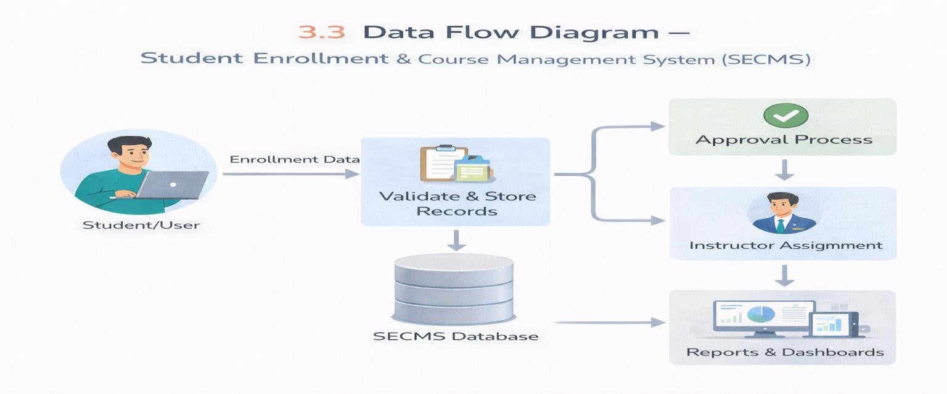

3.4 Technology Stack
 |  | Layer | Technology | Purpose
 |  | User Interface | Salesforce Lightning  Experience | Provides screens and interfaces for users
 |  | Data Model | Salesforce Custom Objects | Stores student, course, faculty, and registration records
 |  | Business Logic | Salesforce Flow | Automates application processes
 |  | Data Validation | Validation Rules | Controls incorrect or incomplete data
 |  | Security | Profiles & Permission Sets | Controls user access and permissions
 |  | Process Control | Approval Process | Handles registration-related approvals
 |  | Communication | Email Alerts | Sends automated notifications
 |  | Analytics | Salesforce Reports | Provides detailed academic information
 |  | Visualization | Salesforce Dashboards | Displays important information in graphical form

4.PROJECT DESIGN PHASE
  - Problem–Solution Fit
SECMS is designed to provide a connected academic management environment where student information, course details, faculty allocation, and registration activities can be handled through Salesforce. The proposed design focuses on reducing repeated data entry, improving information visibility, and providing users with appropriate functionality based on their responsibilities.
The solution connects different academic activities through Salesforce objects and relationships. Automation features help reduce routine work, while validation and security configurations help maintain reliable and controlled access to information.
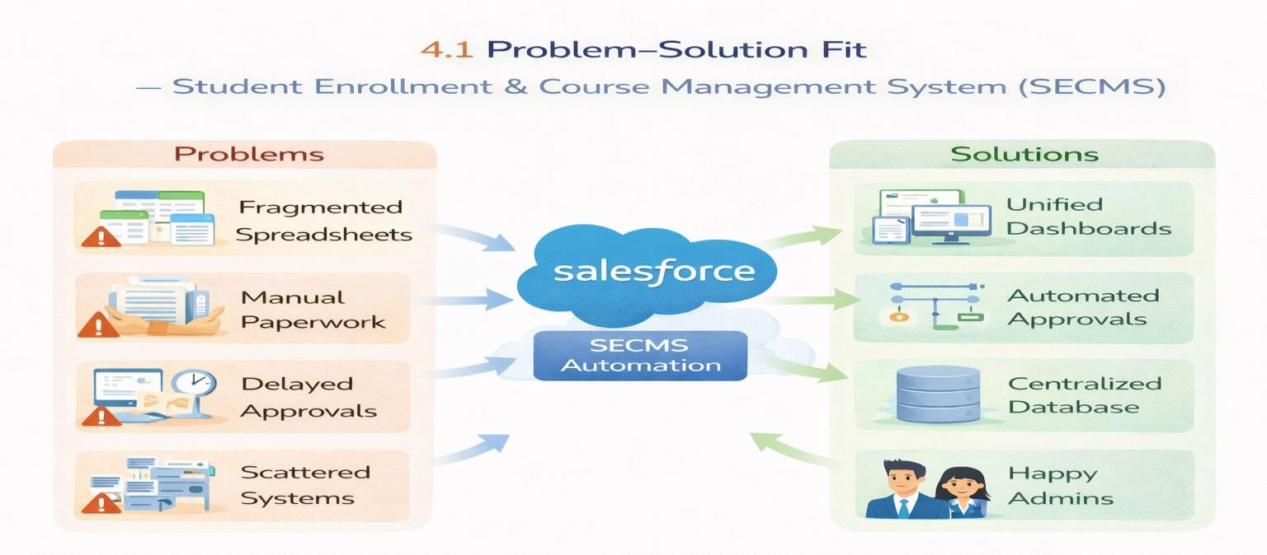
Solution Architecture
The SECMS architecture consists of several connected Salesforce components. Student, Course, Faculty, and Registration information is maintained through Salesforce objects. Relationships between these records allow information to be connected and accessed according to the application's requirements.
Salesforce Flow is used for process automation, while validation rules control data entry. Profiles and permission sets manage access to system functionality. Reports and dashboards use the stored information to provide administrators with summarized academic information.

Architecture Flow:
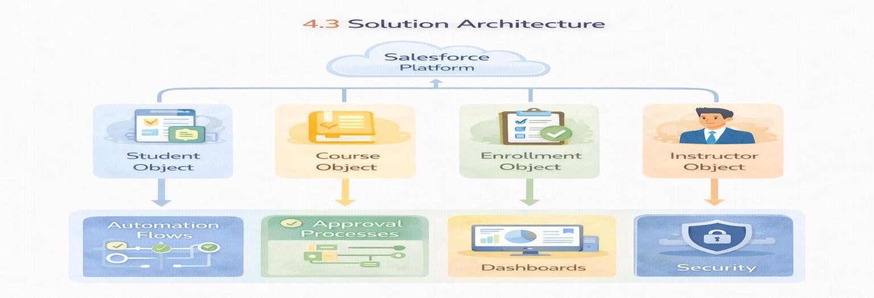

- PROJECT PLANNING & SCHEDULING
  - Project Planning
The project is planned using an iterative development approach. The complete application is divided into smaller functional activities so that each section can be developed and tested progressively.
    - Requirement identification
    - Salesforce environment preparation
    - Data structure development
    - User interface configuration
    - Automation development
    - Security configuration
    - Reporting implementation
    - Testing and refinement

Product Backlog, Sprint Schedule, and Estimation
Sprint | Functional Requirement (Epic) | User Story Number | User Story / Task | Story Points | Priority | Team Members
Sprint-1 | Developer Setup | USN-1 | As a system administrator, I want to create a Salesforce developer account so that I can configure and deploy the Student Enrollment system.. | 1 | High | Member1
Sprint-1 | Data Modeling | USN-2 | As an admin, I want to create custom objects for Student, Course, Enrollment, and Instructor so that academic data can be stored and managed efficiently. | 3 | High | Member2
Sprint-2 | Data Modeling | USN-3 | As a user, I want dedicated tabs for each object so that I can easily navigate between students, courses, enrollments, and instructors. | 3 | High | Member3
Sprint-2 | Data Modeling | USN-4 | As an admin, I want to create relevant fields such as student details, course information, and enrollment status so that complete records can be captured accurately. | 5 | High | Member4
Sprint-2 | Data Modeling | USN-5 | As an enrollment officer, I want a centralized Lightning App so that I can access all academic operations from one interface. | 3 | High | Member4
Sprint-2 | Data Modeling | USN-6 | As an admin, I want to define relationships between students, courses, and enrollments so that the system can logically link and track academic activities. | 5 | Medium | Member1
Sprint-2 | Data Modeling | USN-7 | As a user, I want customized page layouts so that only relevant information is displayed, improving clarity and ease of data entry. | 5 | High | Member2
Sprint-3 | Automation | USN-8 | As a system, I want to validate input data such as mandatory fields and enrollment limits so that incorrect or incomplete records are prevented. | 3 | High | Member4
Sprint-3 | Automation | USN-9 | As a system, I want automated flows to handle enrollment processing and notifications so that manual effort is reduced and processes become faster. | 3 | High | Member4
Sprint-3 | Automation | USN-10 | As an administrator, I want an approval process for enrollment requests so that registrations are verified before confirmation. | 5 | High | Member1
Sprint-4 | Security | USN-11 | As an admin, I want to configure role-based security so that users can only access data relevant to their responsibilities. | 5 | High | Member2
Sprint-5 | Reports | USN-12 | As a manager, I want reports on student enrollments, course registrations, and instructor assignments so that I can monitor academic operations. | 4 | High | Member3
Sprint-6 | Dashboards | USN-13 | As a manager, I want visual dashboards showing enrollment statistics and trends so that I can quickly analyze system performance. | 4 | Medium | Member4

Project Tracker, Velocity & Burndown Chart
Project Tracker, Velocity & Burndown Chart:
Sprint | Total Story Points | Duration | Sprint Start Date | Sprint End Date (Planned) | Story Points Completed (as on Planned End Date) | Sprint Release Date (Actual)
Sprint-1 | 20 | 6 Days | 01-09-2026 | 06-09-2026 | 20 | 06-09-2026
Sprint-2 | 20 | 6 Days | 07-09-2026 | 12-09-2026 | 20 | 12-09-2026
Sprint-3 | 20 | 6 Days | 13-09-2026 | 18-09-2026 | 20 | 18-09-2026

- PROJECT DEVELOPMENT PHASE
Activity 1: Creating Developer Account:
Creating a developer org in salesforce.
Go to https://developer.salesforce.com/signup
On the sign up form, enter the following details :
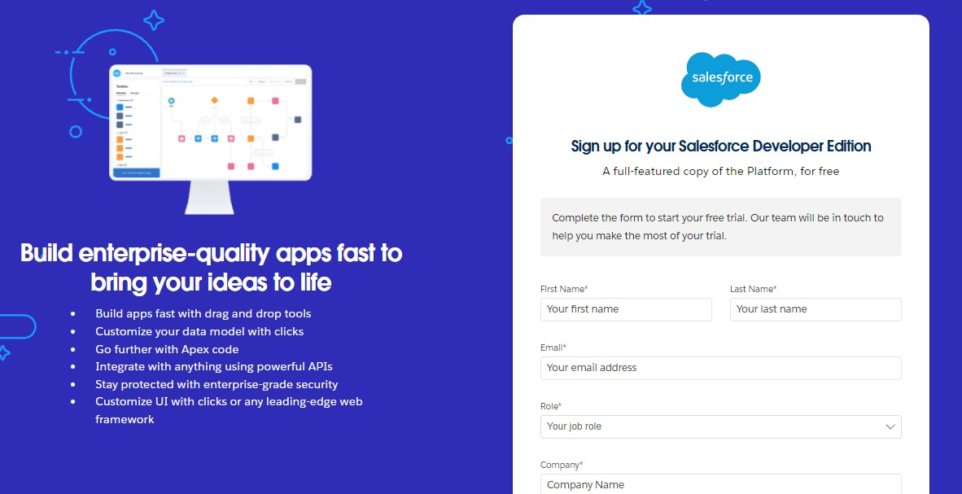

First name & Last name

Email
Role : Developer
Company : College Name
County : India
Postal Code : pin code
Username : should be a combination of your name and company
This need not be an actual email id, you can give anything in the format : username@organization.com
Click on sign me up after filling these.
Activity 2: Account Activation:
- Go to the inbox of the email that you used while signing up. Click on the verify account to activate your account. The email may take 5-10mins.

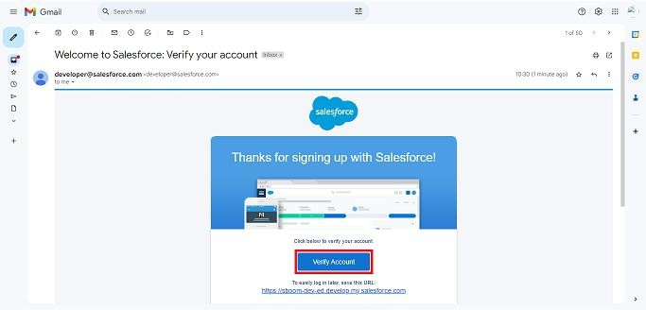
- Click on Verify Account
- Give a password and answer a security question and click on change password.
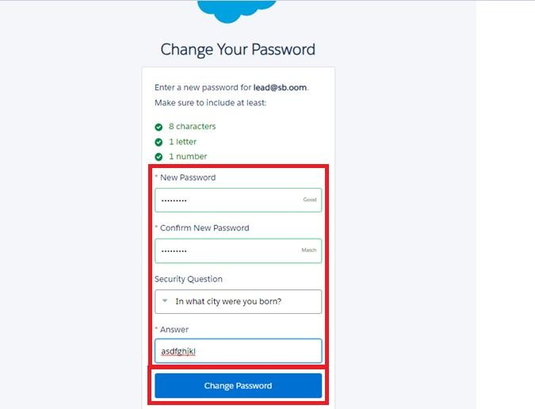

- Then you will redirect to your salesforce setup page.
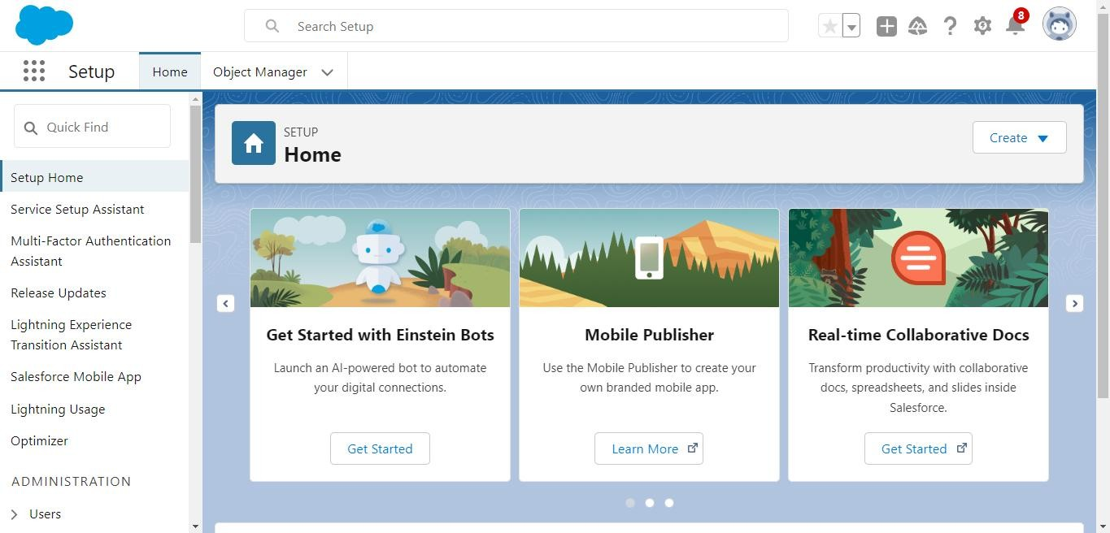

Milestone 2 – Objects:
Activity 1: Creating Student Object:
The purpose of creating the Student custom object is to store and manage information about students such as their personal details, contact information, and enrollment status.

To create the Student object:

Go to the Setup page.

Click on Object Manager.

Click on Create → Custom Object.

Enter the details as below:
  - Label: Student
  - Plural Label: Students
  - Object Name: Student
  - Record Name: Student Name
  - Data Type: Text
  - Under Optional Features, select:
  - Allow Reports
  - Allow Activities (optional but recommended) 9. Track Field History (optional, if you want)
10. Under Search Status, select: 11. Allow Search
12. Click Save.

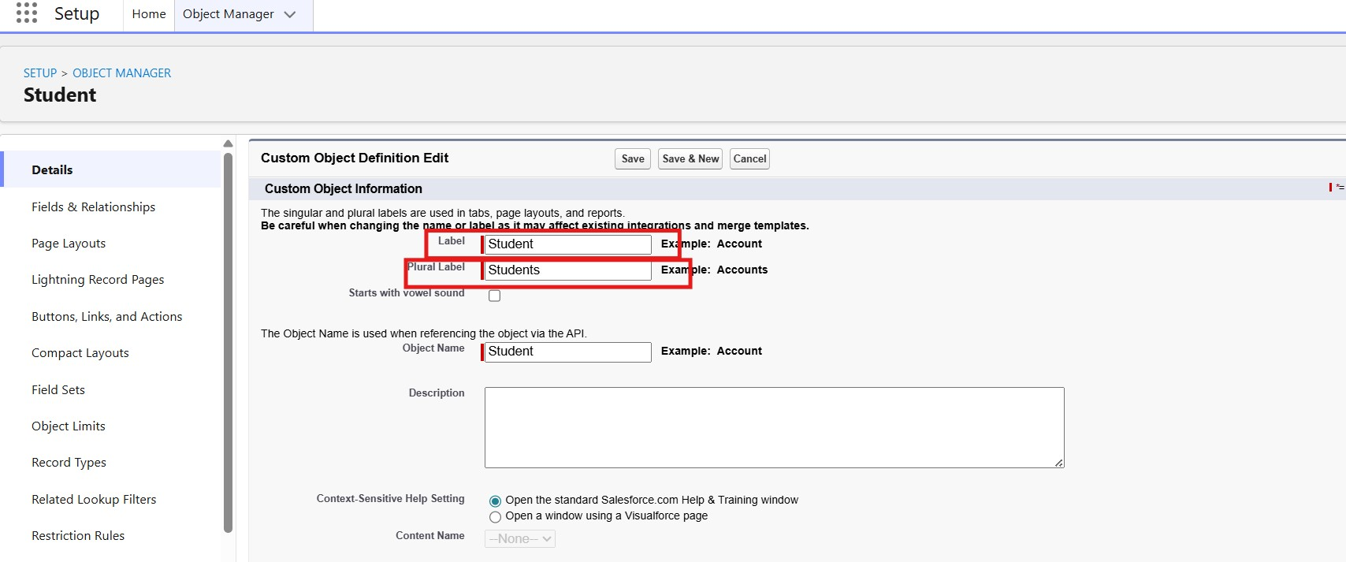

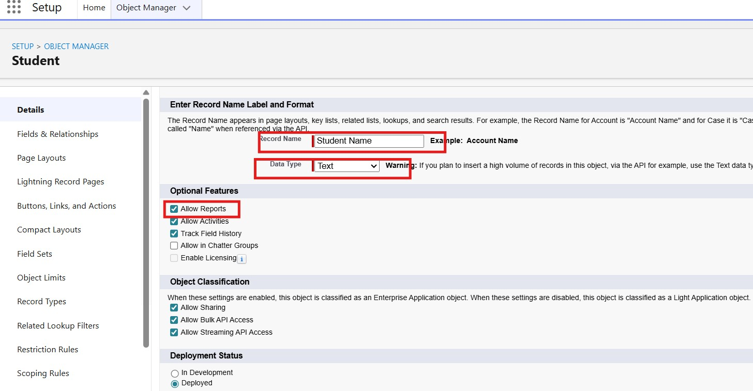

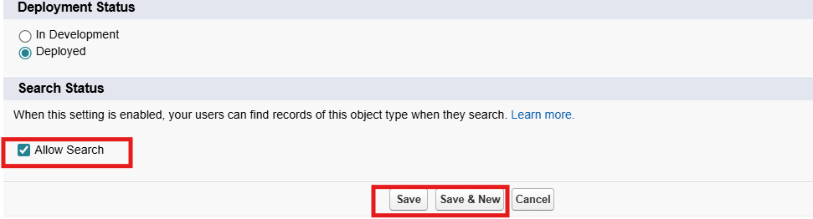

In the same way Create Courses, Instructors, and Enrolments objects

What You'll Learn
  - Creating a Salesforce-based academic application.
  - Designing a suitable Salesforce data model.
  - Connecting records using object relationships.
  - Configuring Lightning pages and user interfaces.
  - Applying business rules to academic records.
  - Creating automated processes using Salesforce Flow.
  - Managing user permissions and access.
  - Preparing meaningful reports and dashboards.
  - Testing application functions systematically.
  - Understanding the complete development lifecycle of a Salesforce project.
Milestone 1 – Salesforce Environment
Introduction
Salesforce provides a cloud-based platform where organizations can configure applications according to their operational requirements. For SECMS, the Salesforce environment acts as the foundation for storing academic information and implementing the required application functionality.
The development environment allows administrators to create objects, fields, relationships, automation processes, security settings, reports, and dashboards without building the entire application from the beginning.
Activity 1: Salesforce Environment Setup
The first activity is to prepare a Salesforce development environment for the SECMS project.
Basic Setup Steps
- Open the Salesforce Developer website.
- Select the option to create a developer account.
- Enter the required personal and organization information.
- Provide a valid email address for account verification.
- Create a unique username for the Salesforce environment.
- Submit the registration form.
- Open the verification email received from Salesforce.
- Verify the account.
- Create a secure password.
- Sign in to the Salesforce environment.
- Open Setup to begin application configuration.
Activity 2: Initial Salesforce Configuration
After successfully entering the Salesforce environment:
- Open the Setup menu.
- Search for Object Manager.
- Review the available standard Salesforce objects.
- Open App Manager to understand application configuration.
- Review Users, Profiles, and Permission Sets.
- Confirm that the development environment is ready for SECMS configuration.
Milestone 2 – Academic Objects
Activity 1: Creating Student Object
The Student object is used to maintain the basic academic profile of students participating in the enrollment process.
Suggested Student Object Configuration
- Label: Student Profile
- Plural Label: Student Profiles
- Object Name: Student_Profile
- Record Name: Student ID
- Data Type: Auto Number
- Display Format: STU-{0000}
- Allow Reports: Enabled
- Allow Activities: Enabled
- Track Field History: Enabled where required
- Allow Search: Enabled
Suggested Student Fields
- Student Full Name
- Date of Birth
- Email Address
- Mobile Number
- Department
- Academic Program
- Year of Study
- Admission Date
- Student Status
The Student object provides the primary student record that can later be connected with course and registration records through Salesforce relationships.
Milestone 3 – Fields
Table 1: Student Object Fields
Field Label | Data Type
Student ID | Text
Full Name | Text
Personal Email | Email
Mobile Number | Phone
Admission Year | Number
Program | Picklist
Academic Year | Picklist
Current Semester | Number
Enrollment Status | Picklist
Permanent Address | Long Text Area

Table 2: Course Object Fields
Field Label | Data Type
Course Code | Text
Course Title | Text
Department | Picklist
Credit Hours | Number
Semester | Number
Course Type | Picklist
Maximum Seats | Number
Course Fee | Currency
Course Description | Long Text Area

Table 3: Instructor Object Fields
Field Label | Data Type
Faculty ID | Text
Full Name | Text
Department | Picklist
Specialization | Text
Qualification | Picklist
Contact Number | Phone
Official Email | Email
Faculty Status | Picklist

Table 4: Enrollment Object Fields
Field Label | Data Type
Registration Number | Auto Number
Student | Lookup (Student)
Course | Lookup (Course)
Faculty | Lookup (Instructor)
Registration Date | Date
Semester | Picklist
Registration Status | Picklist
Payment Status | Picklist
Amount Due | Currency
Remarks | Long Text Area

Milestone 4 – Create Relationships
1. Activity 1: Create Lookup from Enrollment to Student
Purpose:
To associate every course registration record with the appropriate student profile.
Steps:
- Go to Setup → Object Manager.
- Search for Enrollment in Quick Find and open the Enrollment__c object.
- Select Fields & Relationships → New.
- Choose Lookup Relationship and click Next.
- Under Related To, select Student__c and click Next.
- Enter Field Label: Student Profile.
- Configure field visibility and add the field to the required page layouts.
- Click Next and then Save.

Activity 2: Create Lookup from Enrollment to Course
Purpose:
To connect a registration record with the academic course selected by the student.
Steps:
- Go to Setup → Object Manager → Enrollment__c.
- Open Fields & Relationships and click New.
- Select Lookup Relationship and click Next.
- For Related To, choose Course__c.
- Enter Field Label: Selected Course.
- Configure the field-level security and page layout settings.
- Click Save.
Activity 3: Create Lookup from Enrollment to Instructor
Purpose:
To identify the faculty member responsible for the selected course.
Steps:
- Go to Setup → Object Manager → Enrollment__c.
- Click Fields & Relationships → New.
- Select Lookup Relationship and click Next.
- In Related To, select Instructor__c.
- Enter Field Label: Assigned Faculty.
- Configure field visibility and page layout options.
- Click Save.

Milestone 5 – Validation Rules
Activity 1: Validate Student Admission Year
Purpose:
To prevent users from entering an invalid or future admission year while creating a student record.
Steps:
- Go to Setup → Object Manager → Student__c.
- Select Validation Rules and click New.
- Enter Rule Name: Valid_Admission_Year.
- Enter the following error condition formula:
Admission_Year__c > YEAR(TODAY())
- Enter Error Message:
Admission year cannot be later than the current year.
- Select Field: Admission_Year__c as the error location.
- Click Save.
Image
Activity 2: Course Seat Limit Validation
Purpose:
To prevent a course from being marked as available when its configured capacity is zero or negative.
Steps:
- Go to Setup → Object Manager → Course__c.
- Click Validation Rules → New.
- Enter Rule Name: Course_Seat_Limit_Check.
- Enter the following error condition formula:
Maximum_Seats__c <= 0
- Enter Error Message:
Maximum seats must be greater than zero.
- Set the error location to Maximum Seats.
- Click Save.
Image
Milestone 6 – Approval Process
Activity 1: Create Approval Process for Course Registration
Purpose:
To send student registration requests to the academic coordinator for verification before final confirmation.
Steps:
- Go to Setup → Approval Processes and select Enrollment__c.
- Click Create New Approval Process → Use Standard Setup.
- Enter Process Name:
Course_Registration_Approval
- Set the entry criteria as:
Registration_Status__c = "Submitted"
- Configure the approval request to be assigned to the Academic Coordinator.
- Define the approval actions to update the registration status after approval.
- Define the rejection action to return the registration to the appropriate status.
- Save the approval process and activate it after completing the configuration.
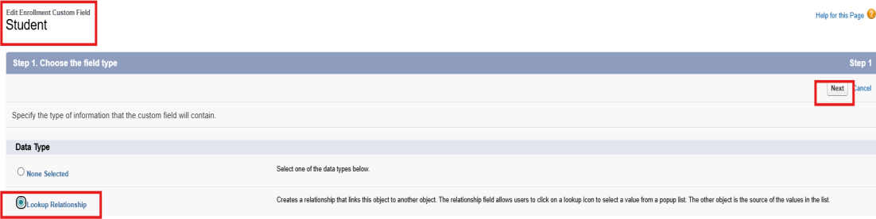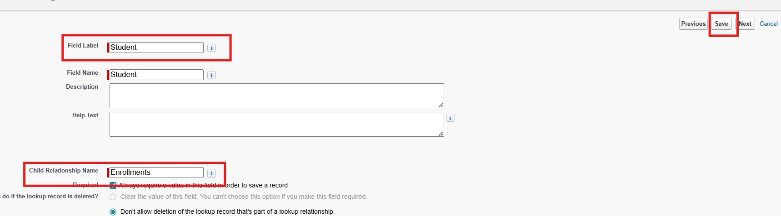
9.

Activity 2: Create Lookup from Enrollment to Course
Purpose:
To associate each registration record with the academic subject selected by the student.
Steps:
- Go to Setup → Object Manager → Enrollment__c.
- Click Fields & Relationships → New.
- Select Lookup Relationship and click Next.
- Under Related To, select Course__c and click Next.
- Configure the required Field-Level Security and Page Layout settings.
- Click Next → Save.
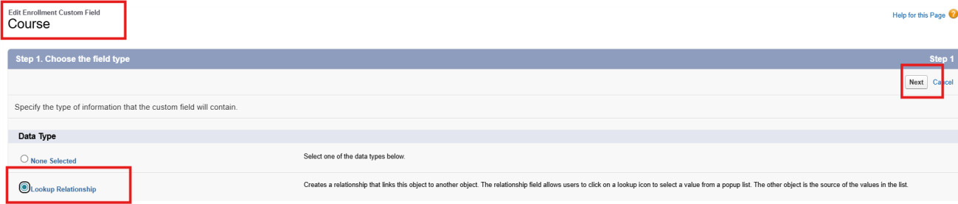
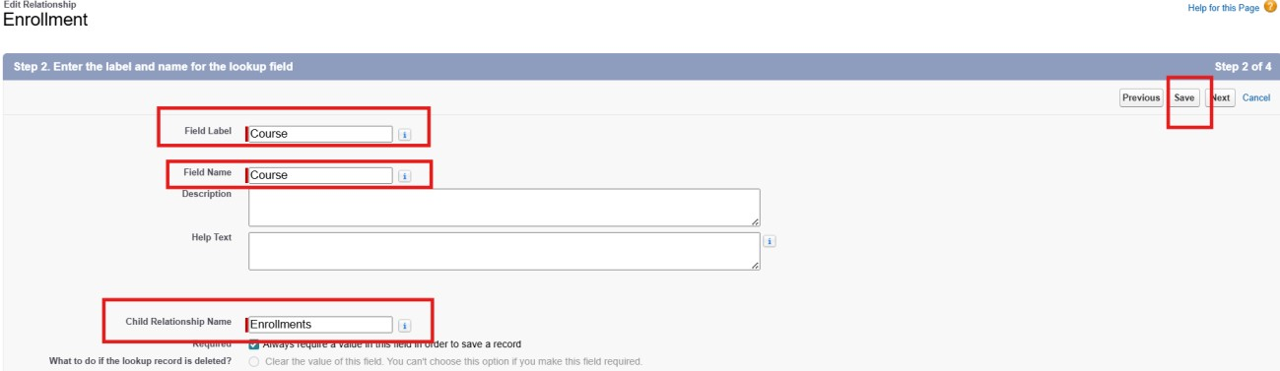
Activity 3: Create Lookup from Enrollment to Instructor
Purpose:
To connect a course registration with the faculty member responsible for that course.
Steps:
- Go to Setup → Object Manager → Enrollment__c.
- Open Fields & Relationships and click New.
- Select Lookup Relationship and click Next.
- In Related To, choose Instructor__c and click Next.
Enter Field Label: Assigned Faculty
API Name: Assigned_Faculty__c
- Configure the Field-Level Security and Page Layout settings according to the application requirements.
- Click Next → Save.
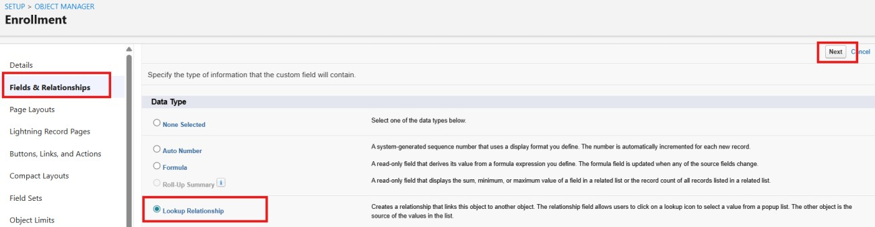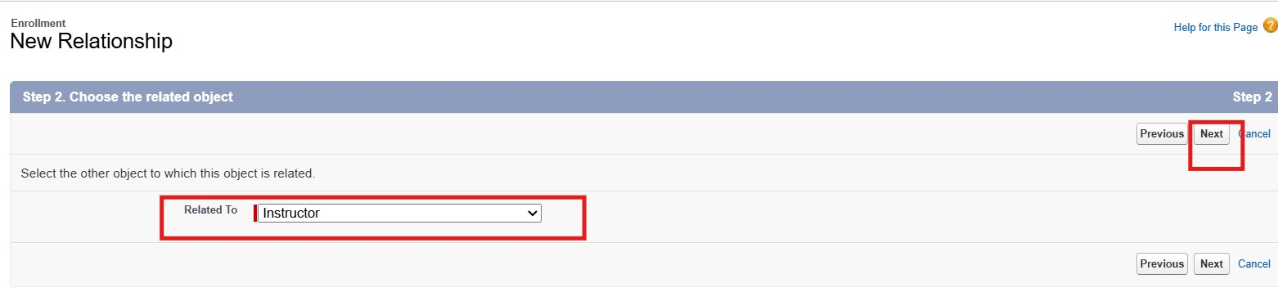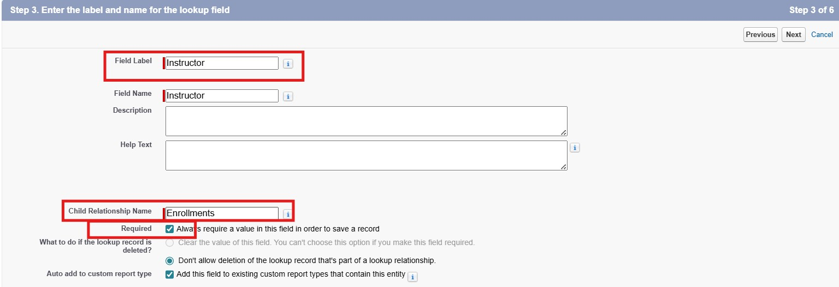
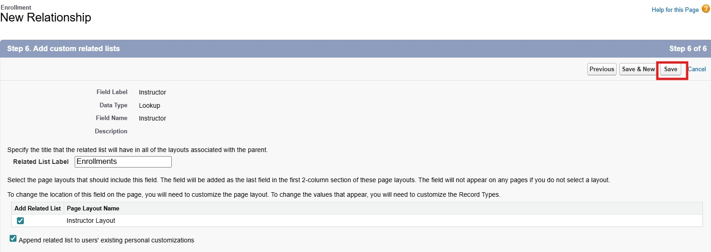

Milestone 5 – Validation Rules
Activity 1: Student Mobile Number Validation
Purpose:
To ensure that the student contact number is entered correctly before the student record is saved.
Steps:
Go to Setup → Object Manager → Student__c.
Click Validation Rules → New.
Rule Name: Student_Mobile_Number_Check.
Error Condition Formula:
OR(
ISBLANK(Phone__c), LEN(Phone__c) <> 10
)
Error Message:
Please enter a valid 10-digit student mobile number.
Error Location: Field → Phone__c.
Click Save.
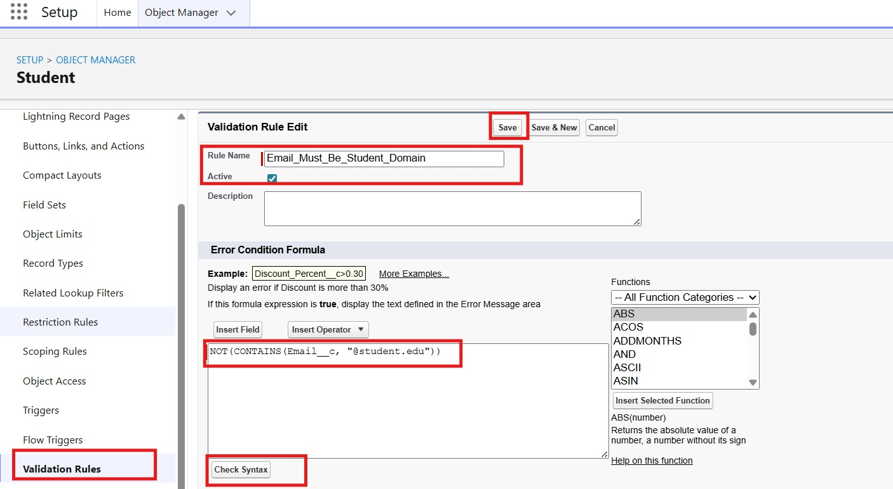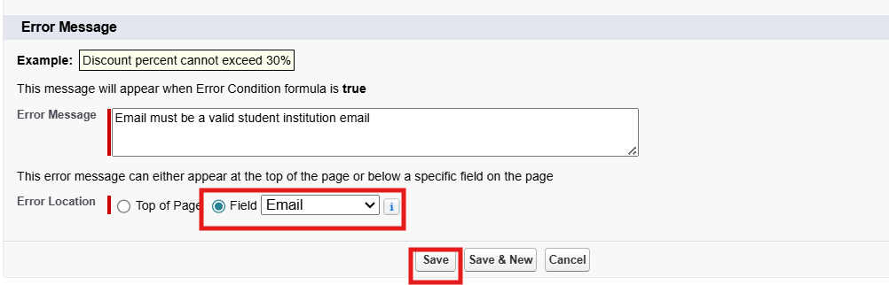
Activity 2: Registration Status Validation
Purpose:
To prevent an enrollment record from being marked as confirmed when the required course selection is missing.
Steps:
- Go to Setup → Object Manager → Enrollment__c.
- Click Validation Rules → New.
- Rule Name: Registration_Course_Required.
- Error Condition Formula:
AND(
ISPICKVAL(Registration_Status__c, "Confirmed"),
ISBLANK(Selected_Course__c)
)
- Error Message:
A course must be selected before confirming the registration.
- Error Location: Field → Selected_Course__c.
Click Save.
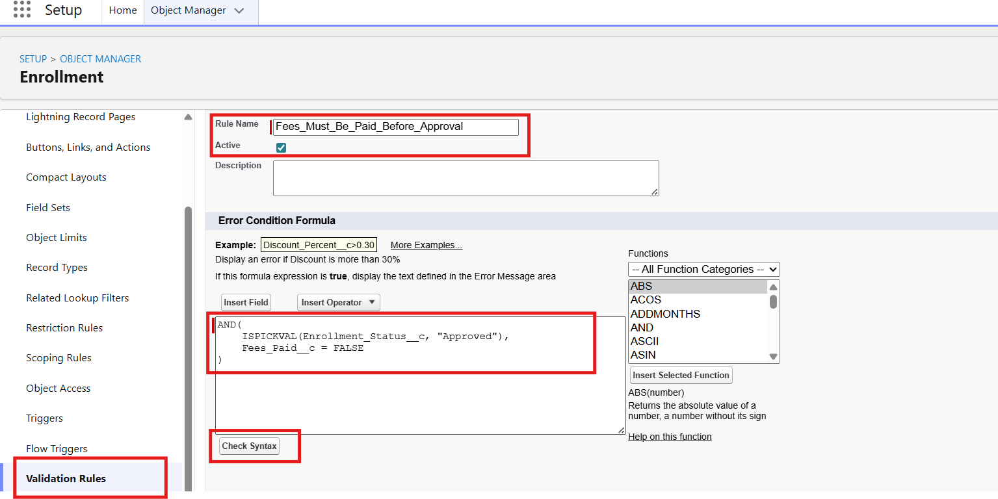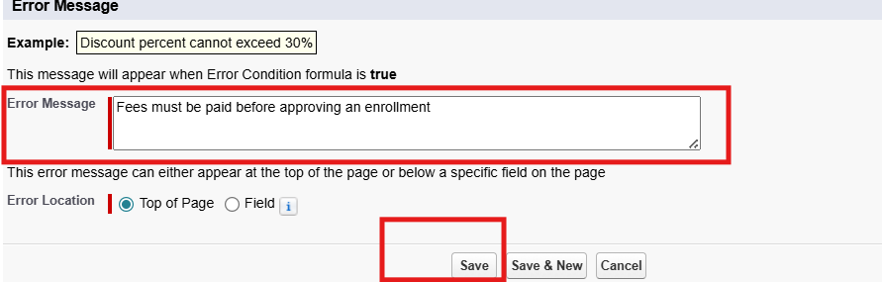
Milestone 6 – Approval Process
Activity 1: Create Approval Process for Course Registration
Purpose:
To forward submitted course registration records to the Academic Coordinator for verification and approval.
Steps:
1. Go to Setup → Approval Processes → select Enrollment__c. 2. Click Create New Approval Process → Use Standard Setup.
Process Name:
Course_Registration_Verification.
Entry Criteria:
Registration_Status__c = "Submitted"
- Select the appropriate Approver such as the Academic Coordinator.
- Configure the Approval Actions and Rejection Actions to update the registration status.
- Save and Activate the approval process after completing the configuration.
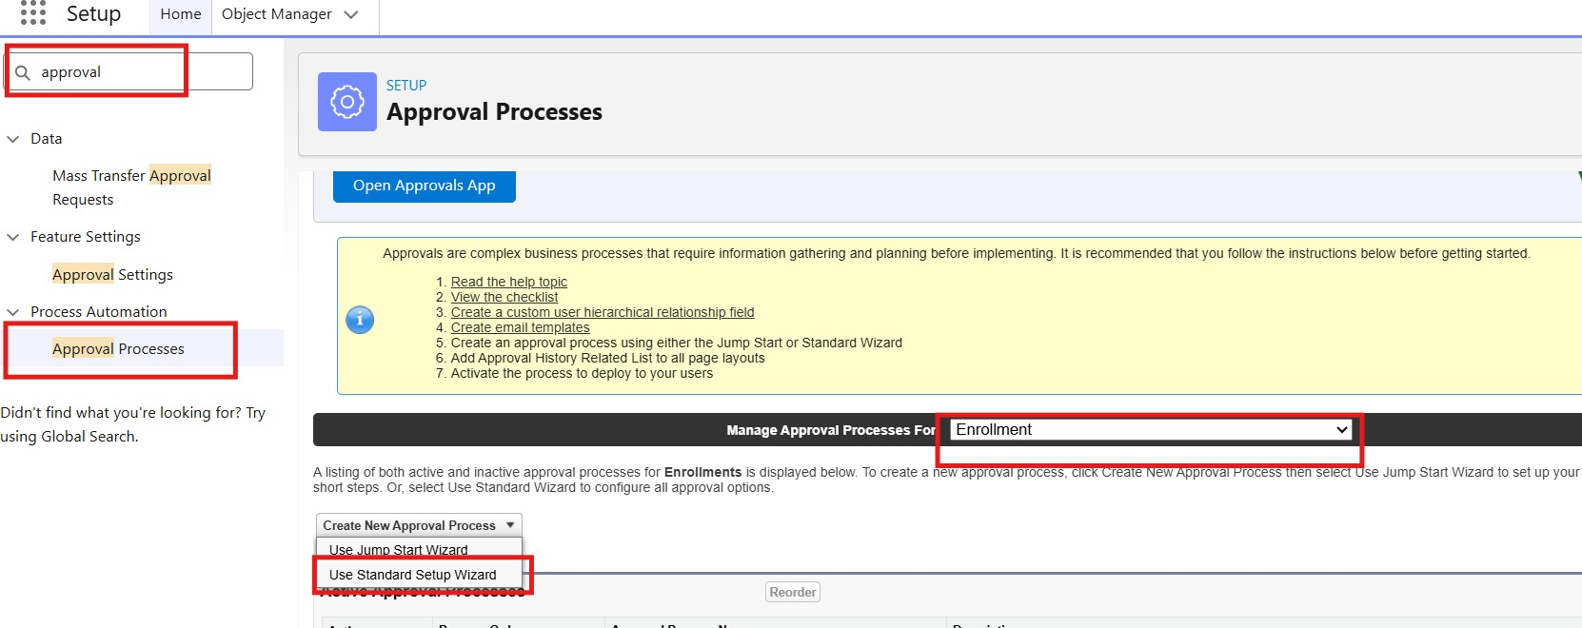
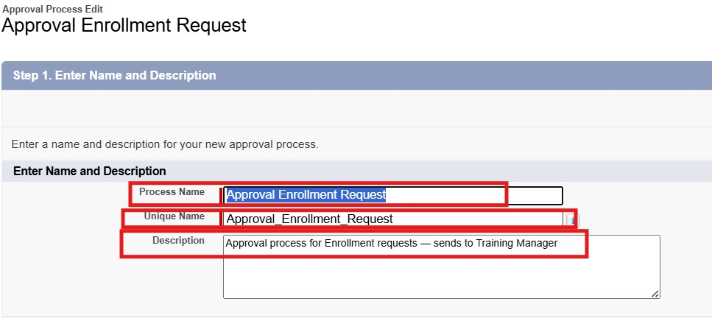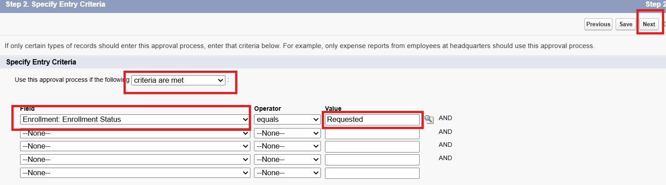
- Add Approval Step:
- Approver: specific Training Manager user.
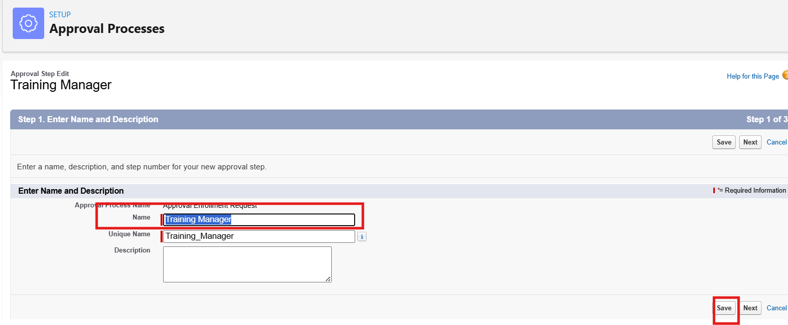
- Under Final Approval Actions:
- Add Field Update to set Enrollment_Status__c = "Approved".
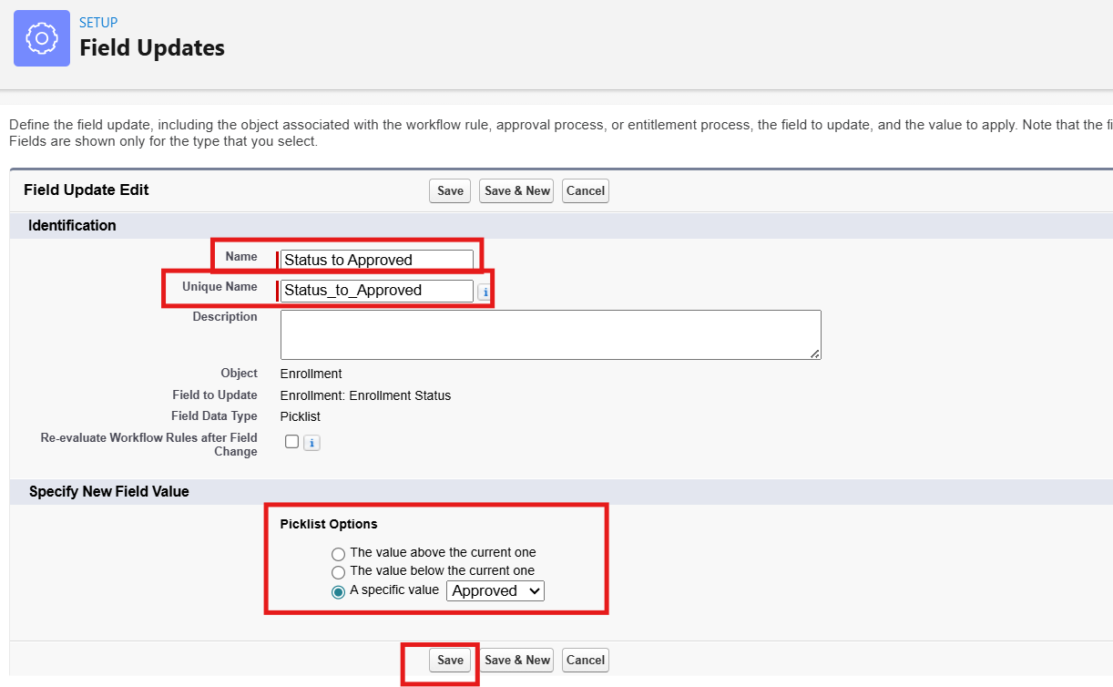
  - Under Final Rejection Actions:
  - Add Field Update to set Enrollment_Status__c = "Rejected".
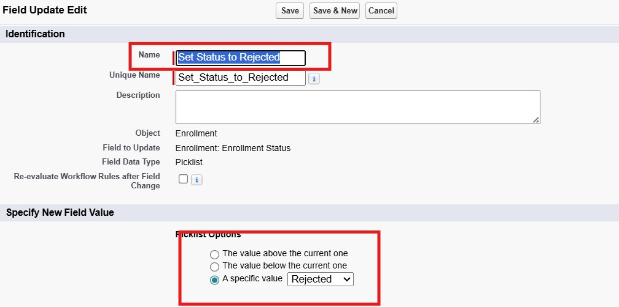
1. Add Email Alert to send rejection email to student.

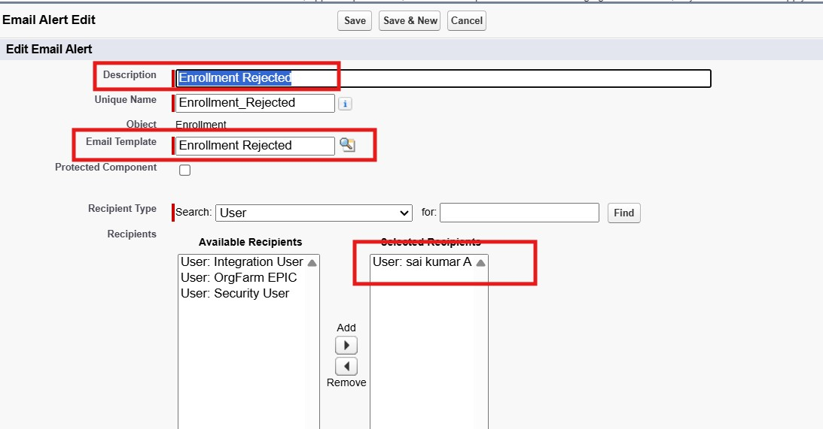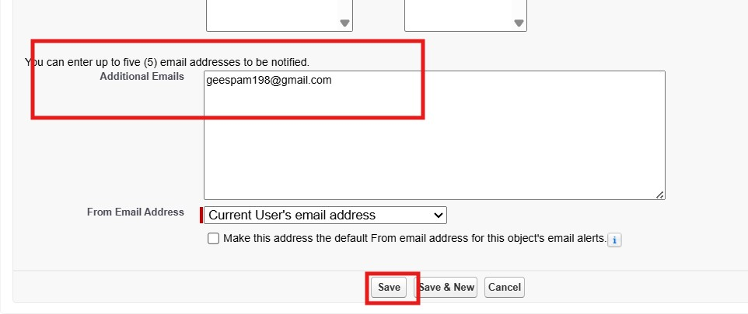
- Activate the approval process.

Milestone 7- Tabs
Activity 1: Creating a Tab for the Student Object:
Go to Setup.
  - In the Quick Find box, type Tabs.
  - Under Custom Object Tabs, click New.
  - Select Student from the object list.
  - Choose a tab style (icon).
  - Click Next, assign it to all profiles, and then click Save.

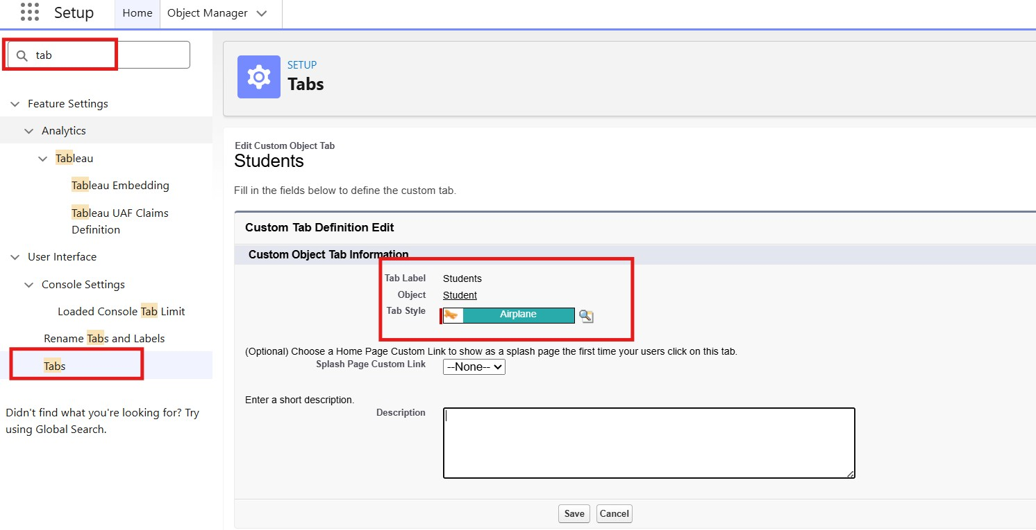
Activity 2: Creating Remaining Tabs
After creating the Student tab, create tabs for the other academic objects used in the system.
The remaining tabs are Course, Faculty, and Registration.
Follow the custom tab creation procedure used in the previous activity and create each tab individually.

Milestone 8 – The Lightning App
Activity 1: Creating the Lightning Application for the Project
Navigate to Setup.
Enter App Manager in the Quick Find search box.
Click New Lightning App.
Provide the application details:
App Name: Academic Registration Portal
Developer Name: Automatically generated by Salesforce
Description: A centralized application for managing student profiles, academic courses, faculty assignments, and registration activities.
Click Next and configure the following settings:
App Branding: Add a suitable application logo and select an appropriate theme.
Navigation Style: Select Standard Navigation.
Click Next and assign the application to the required user profiles, such as System Administrator, Academic Coordinator, and Faculty.
Click Next to select the items that should appear in the application navigation bar. Add:
- Student Profiles
- Courses
- Faculty
- Registrations
- Programs
- Reports
- Dashboards
- Home
Click Next and review the application configuration.
Finally, click Save & Finish.
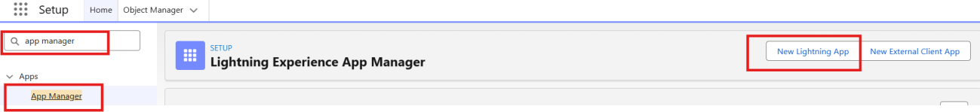
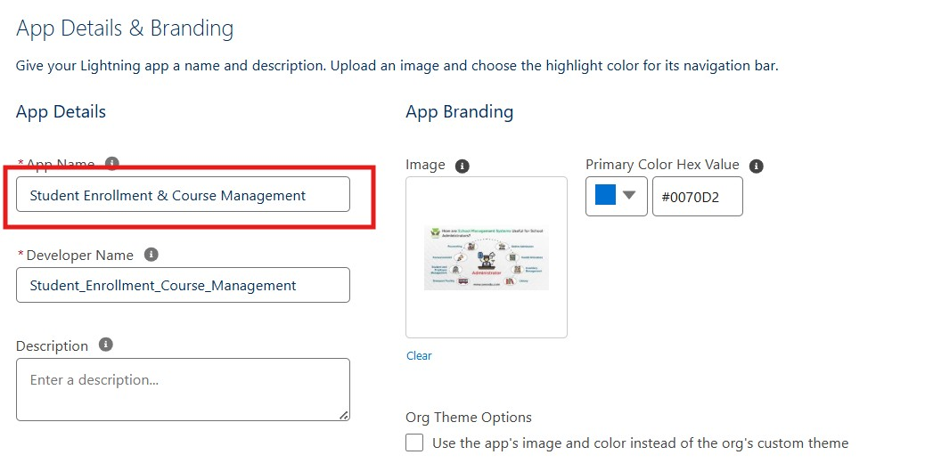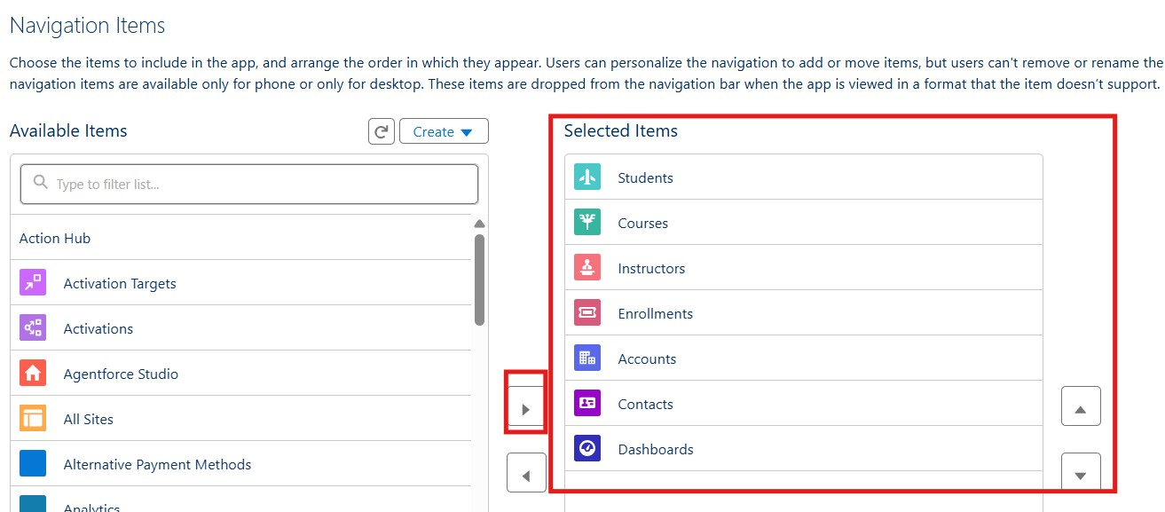

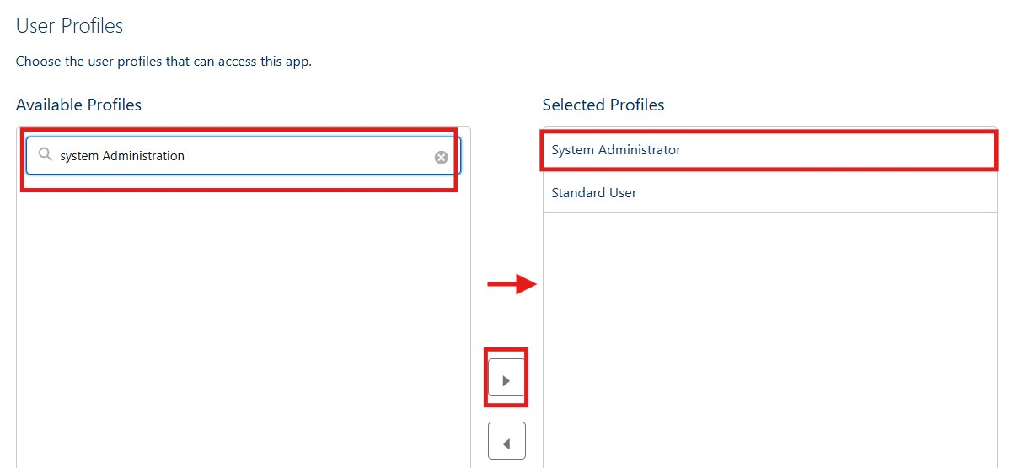
Milestone 9 – Page Layouts and Record Types
Activity 1: Create Record Types for Student Registration
Purpose:
To provide separate registration workflows for Regular Registration and Late Registration.
Steps:
- Go to Setup → Object Manager → Enrollment__c.
- Click Record Types → New.
- For the first record type:
- Existing Record Type: Master
- Record Type Label: Regular Registration
- Enable the record type for the required profiles such as System Administrator and Academic Coordinator.
- Select the appropriate Page Layout and click Save & New.
4. For the second record type:
- Record Type Label: Late Registration
- Enable it for the required academic staff profiles.
- Select the required Page Layout.
- Click Save.
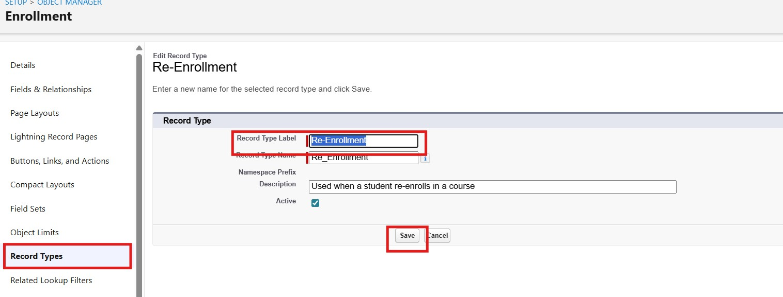
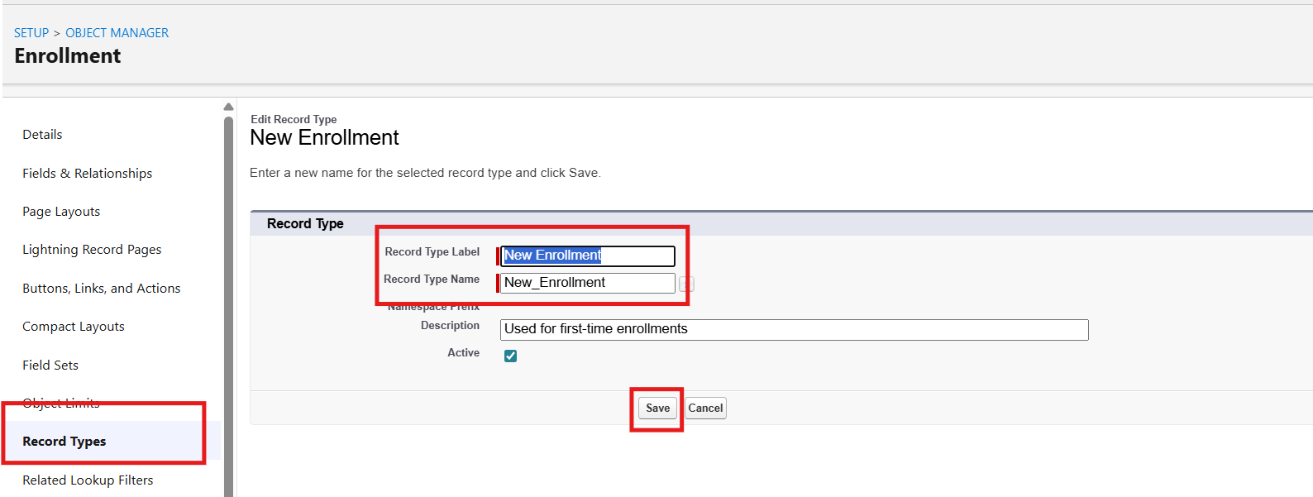
Activity 2: Separate Page Layouts for Each Registration Record Type
Purpose:
To display different information according to the type of course registration being processed.
Steps:
  - Go to Enrollment__c object → click Page Layouts.
  - Click New to create a layout for Regular Registration:
- Clone an existing Enrollment Layout → enter the name Regular Registration Layout → click Save.
- Keep fields related to standard registration such as Registration Number, Student Profile, Selected Course, Registration Date, Semester, Payment Status, and Remarks.
- Remove fields that are not required for normal registration processing.
- Arrange the fields in suitable sections for easy data entry.
- Click Save.
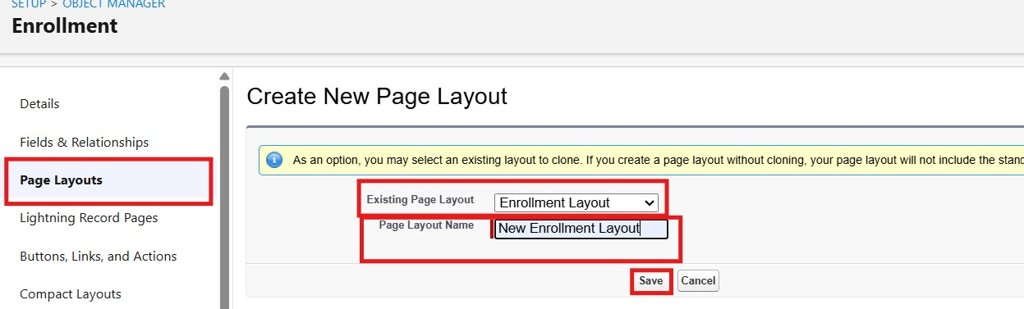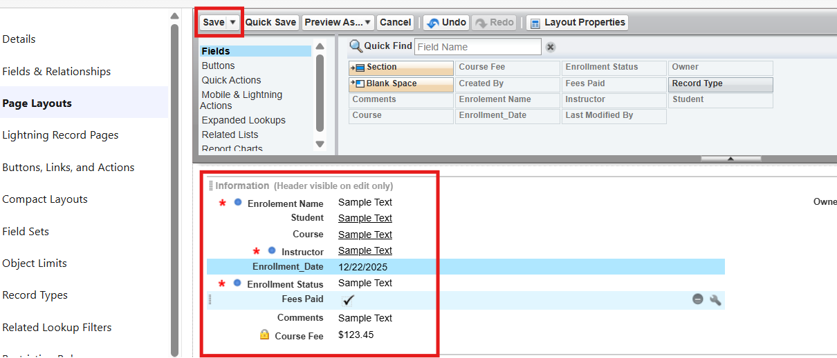

  - Again, click New to create the Late Registration Layout:
- Clone the existing registration layout → enter the name Late Registration Layout → click Save.
- Include fields such as Registration Number, Student Profile, Selected Course, Late Registration Reason, Submission Date, Payment Status, and Coordinator Remarks.
- Remove fields that are not applicable to late registration.
- Arrange the fields into appropriate sections for easier review.
- Click Save.
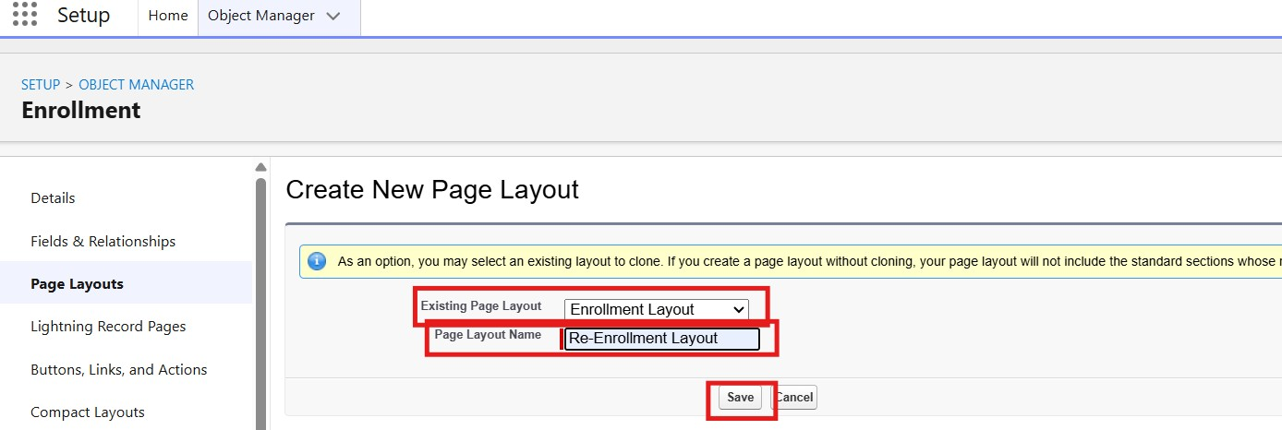
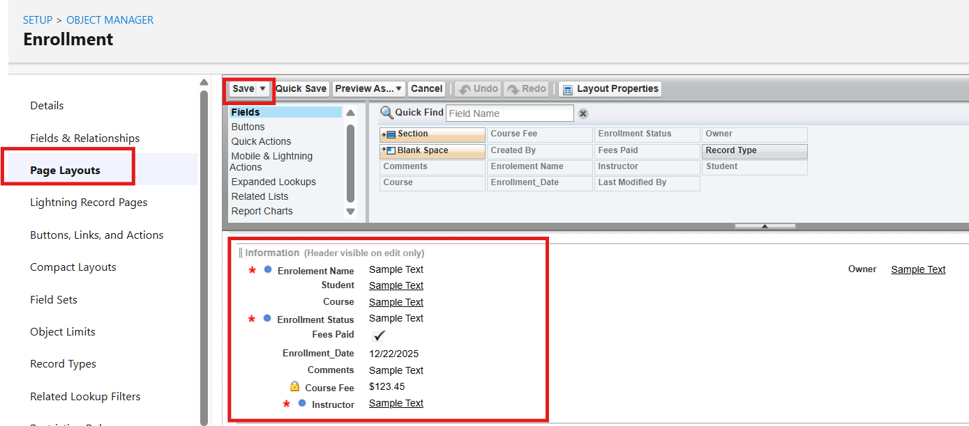
  - Click Page Layout Assignment → Edit Assignment.
  - Assign the appropriate layout for each profile and record type:
- Regular Registration → select Regular Registration Layout.
  - Late Registration → select Late Registration Layout.
Click Save.

Activity 3: Add Registration Related Lists to Parent Objects
Purpose:
To display the registration records associated with each Student, Course, and Faculty record.
- Student → Registration Related List
Go to Setup → Object Manager → Student__c.
Click Page Layouts and open the required student layout.
From the palette, select Related Lists.
Drag the Enrollments related list into the appropriate section of the layout.
Configure the displayed columns if required → click Save.
- Course → Registration Related List
Go to Object Manager → Course__c → Page Layouts.
Open the required course layout.
Add the Enrollments related list to the layout.
Arrange the related-list columns as required → click Save.
- Instructor → Registration Related List
Go to Object Manager → Instructor__c → Page Layouts.
Open the required faculty layout.
Add the Enrollments related list.
Configure the columns and click Save.

Milestone 10 – Automation with Flow
Activity 1: Automatically Set Registration Submission Date
Purpose:
To automatically record the date when a new course registration is submitted, reducing manual date entry.
Steps:
  - Go to Setup → Flows → New Flow.
  - Select Record-Triggered Flow → click Create.
  - Select the object Enrollment__c.
  - Configure the trigger to run when a record is created.
  - Set the flow to run After the record is saved so that the registration date can be updated automatically.
  - Add an Assignment element to assign the current date to the appropriate registration date field.
  - Connect the elements in the flow.
  - Click Save, provide a suitable Flow Label, and Activate the flow.
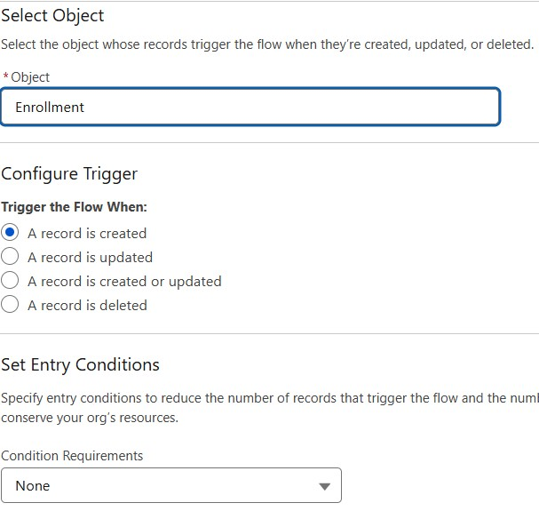
1. Add Update Records element:
- Label: Update Registration Date.
- Select Use the record that triggered the flow.
- Field: Registration_Date__c → Value: $Flow.CurrentDate.
7. Save the flow as UpdateRegistrationDate → click Activate.
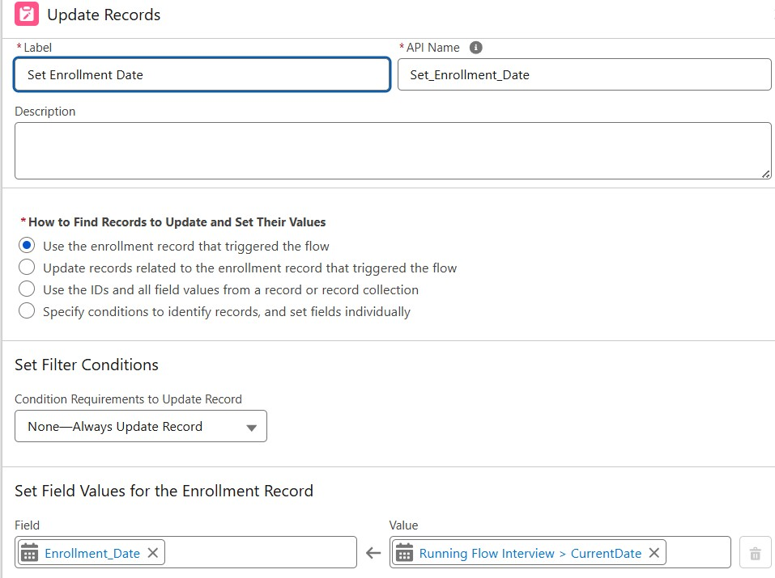
Activity 2: Send Notification When Registration Is Confirmed
Purpose:
When a student's registration status changes to Confirmed, automatically notify the student, inform the academic coordinator, and update the student's academic status.
Steps
(high level for document):
  - Create an appropriate Email Template and Email Alert for registration confirmation.
  - Go to Flows → New Flow → Record-Triggered Flow.
  - Select Enrollment__c as the object and configure the flow to run when an existing registration record is updated.
  - Set the condition:
Registration_Status__c Equals "Confirmed".
  - Add an Email Alert action to send the confirmation message to the student.
  - Add an Update Records element to change the student's status to Active.
  - Save the flow with a suitable name such as RegistrationConfirmationNotification and click Activate.
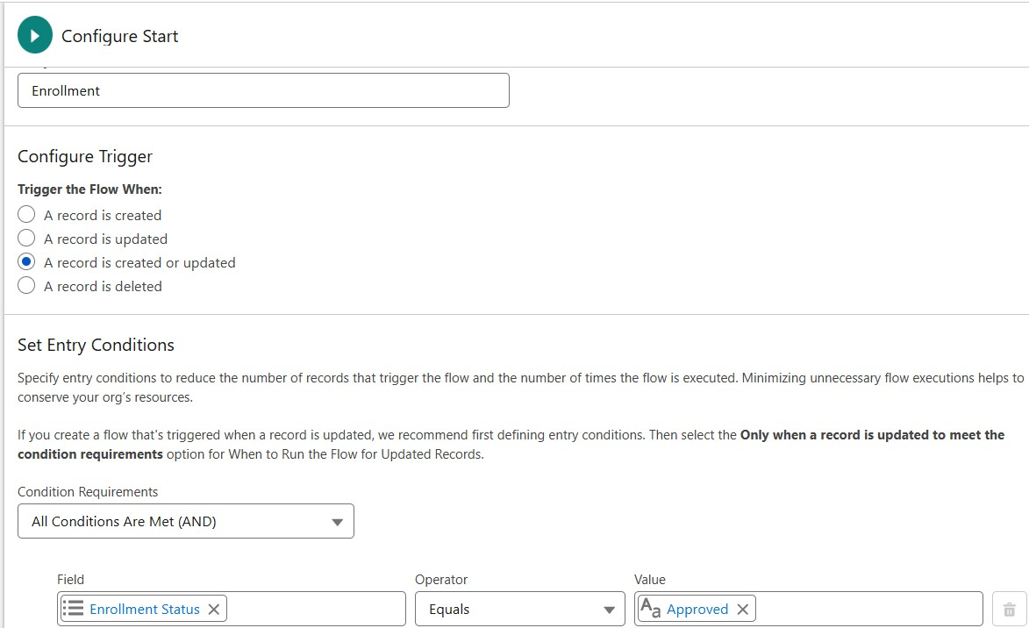
5.Add Get Records to fetch related Student__c.
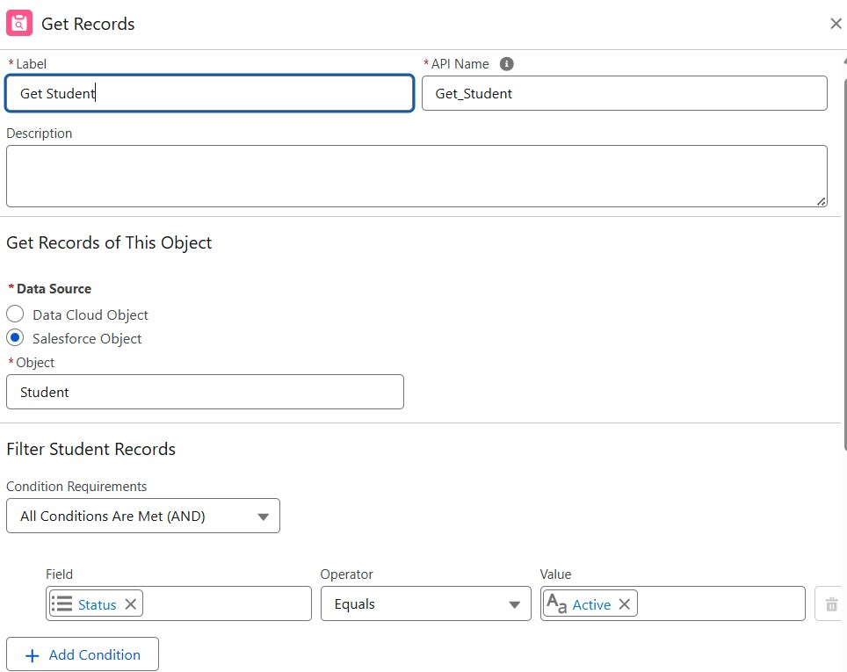
6.Add Action (Email Alert) to send email to student.
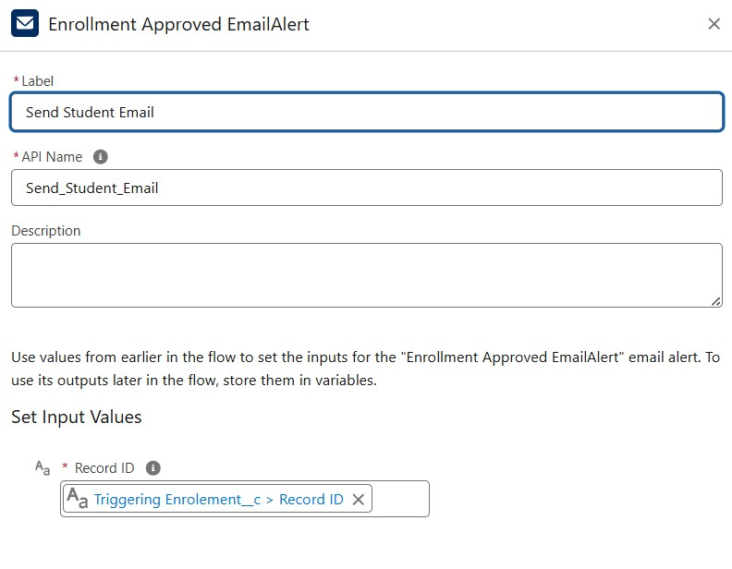
7.Add Action to notify Admin if needed.
8.Add Update Records to set Student__c.Status__c = "Active".
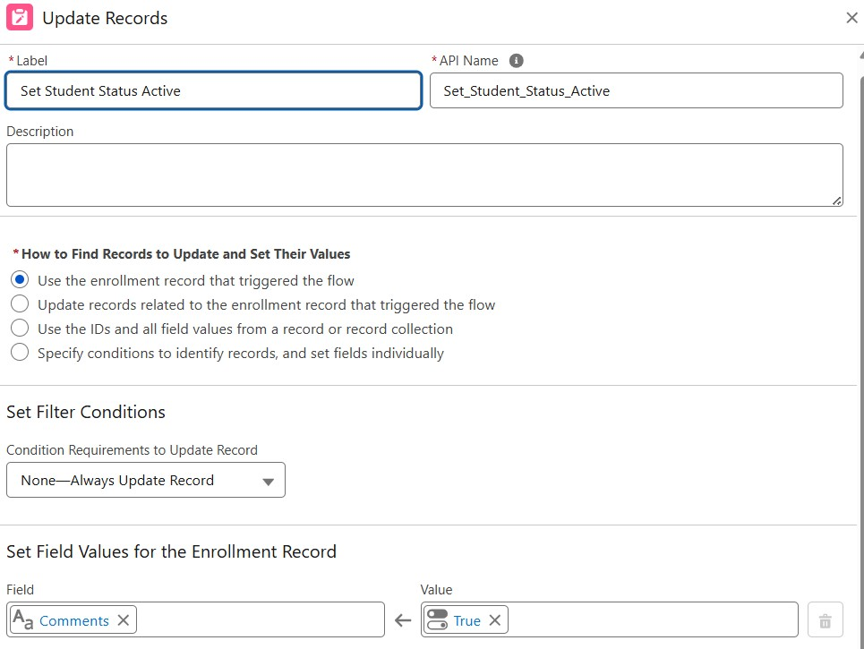

1. Save the previous flow as RegistrationConfirmationAction → click Activate.

Activity 3: Automatically Assign Faculty Based on Course Department Purpose:
To automatically associate a suitable faculty member with a registration according to the department of the selected course.
Rules:
Computer Science → Faculty CS
Commerce → Faculty Commerce Humanities → Faculty Humanities Steps:
  - Prepare Instructor__c records with unique identification codes, such as FAC_CS, FAC_COM, and FAC_HUM.
  - Create a Record-Triggered Flow on Enrollment__c that runs when a registration is created or updated.
  - Add a Get Records element to retrieve the related Course__c record.
  - Add a Decision element based on the course's Department__c value.
  - Create separate outcomes for Computer Science, Commerce, and Humanities.
  - For each outcome:
  - Add a Get Records element to find the corresponding faculty record using its faculty code.
  - Add an Update Records element and assign the selected faculty record to Instructor__c.
  - Save the flow as AutoAssignFacultyByDepartment → click Activate.

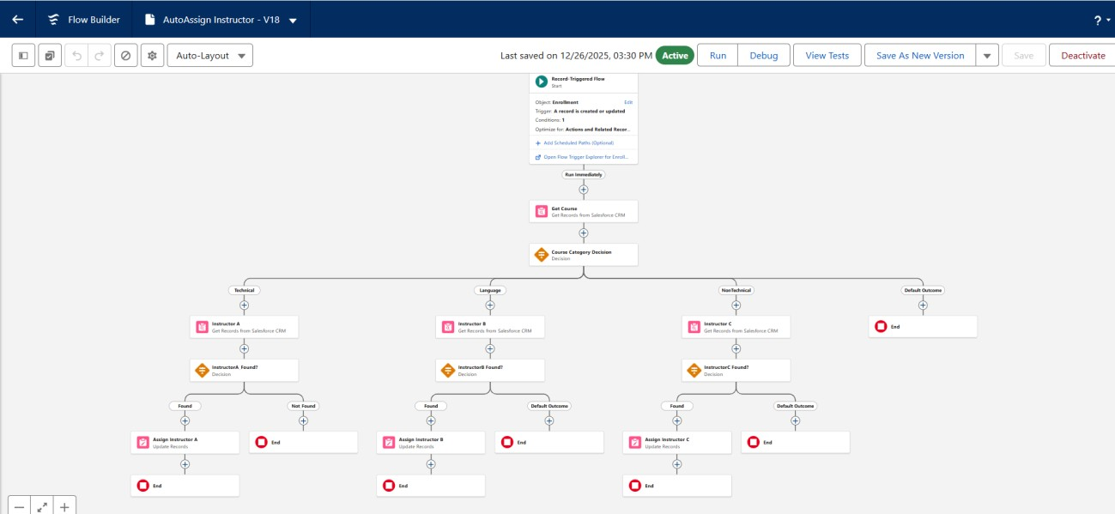
Activity 4: Automatically Create a Review Task Purpose:
When a course registration is submitted, automatically create a task for the Academic Coordinator to review the registration details.
Steps:
  - Create a Record-Triggered Flow on Enrollment__c.
  - Configure the trigger to run when a registration record is created or updated.
  - Set the entry condition:
Registration_Status__c = "Submitted".
  - Add a Create Records element to generate a new Task.
  - Configure the task details:
- Subject: Review Course Registration
- Status: Not Started
- Priority: Normal
- Due Date: $Flow.CurrentDate + 2
  - Click Activate.
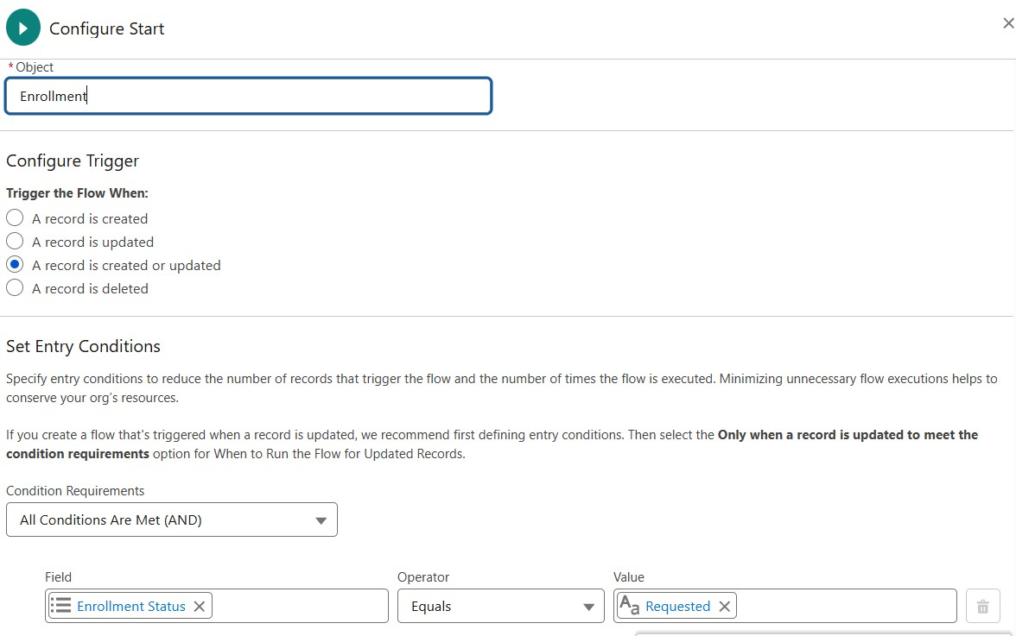
3.Add Get Records to fetch Admin user (by Username / Profile).
4.Add Formula (Date): TODAY() + 2 for due date.
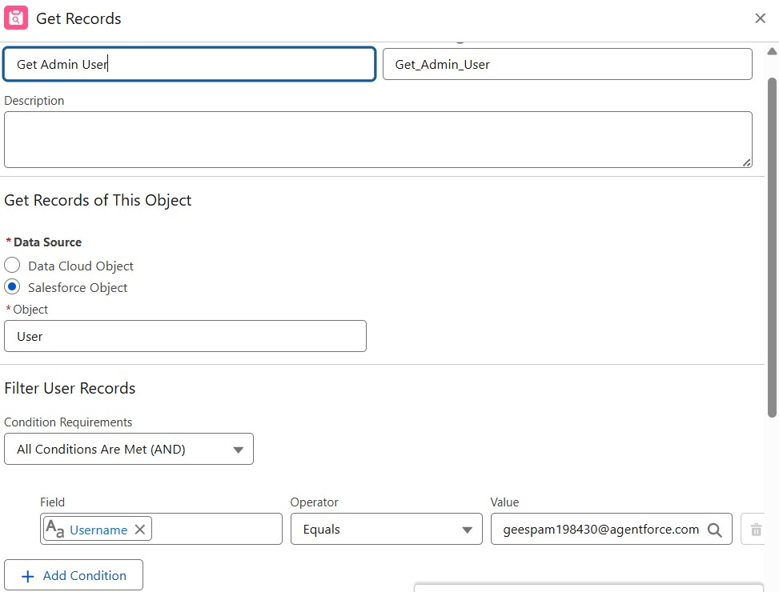
- Add Create Records for Task:
- Subject: Follow up on enrollment request.
- OwnerId: Admin user Id.
- WhatId: Enrollment Id.
- ActivityDate: formula Today + 2.
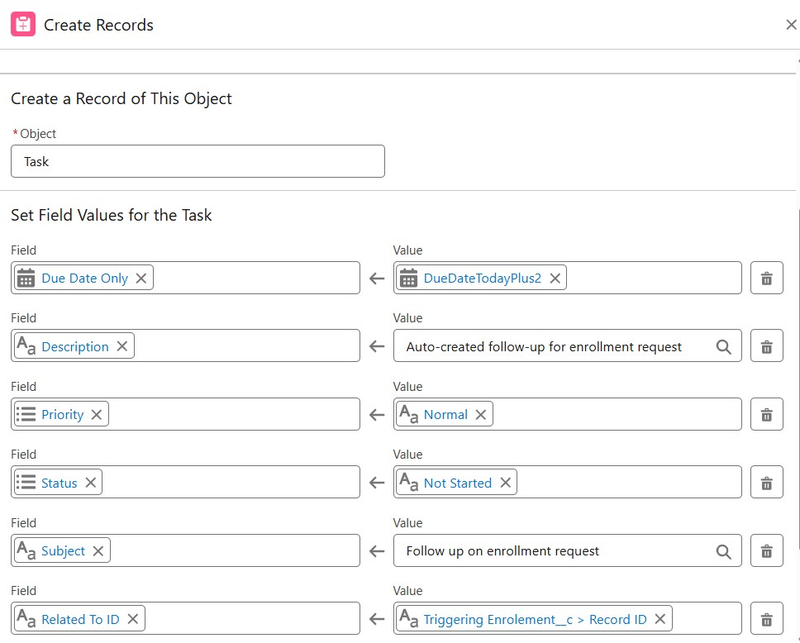
1. Save the flow as Generate_Registration_Task → click Activate.
Milestone 11 – Reports
Activity 1: Create “Course Registrations by Status” Report
- Go to Reports → New Report.
- Select the Enrollments report type.
- Group the report rows by Registration_Status__c.
- Add relevant columns such as Registration Number, Student, Selected Course, Registration Date, and Payment Status.
- Apply filters if required to display only active registration records.
- Save the report as Course Registrations by Status.
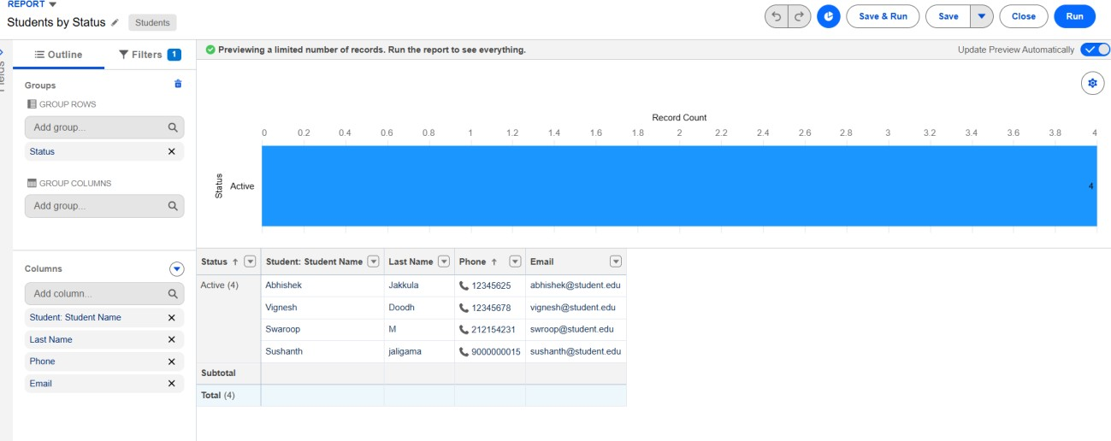
Activity 2: Create “Registrations by Department” Report
- Go to Reports → New Report and select the Enrollments report type.
- Group the report rows by Course__r.Department__c.
- Display the record count for each department to understand registration distribution.
- Add useful columns such as Student, Course, Registration Date, and Registration Status.
- Save the report as Registrations by Department.
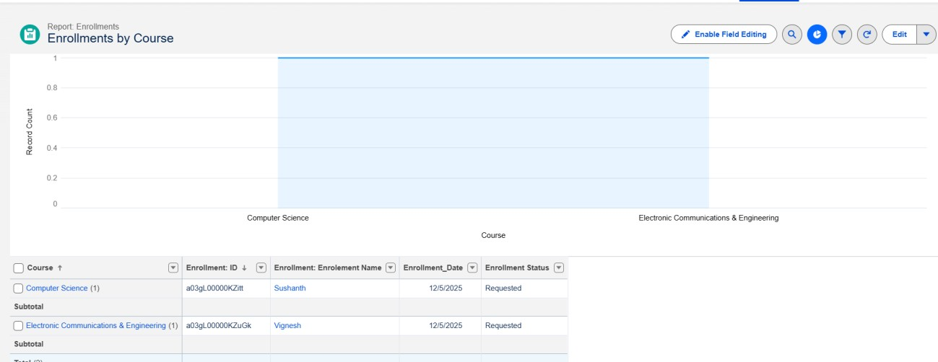
Activity 3: Create “Unprocessed Course Registrations” Report 1. Go to Reports → New Report and select the Enrollments report type.
- Apply the filter:
Registration_Status__c = "Submitted".
- Add columns such as Registration Number, Student, Selected Course, Registration Date, and Assigned Faculty.
- Sort the report by Registration Date to identify recently submitted registrations.
- Save the report as Unprocessed Course Registrations.
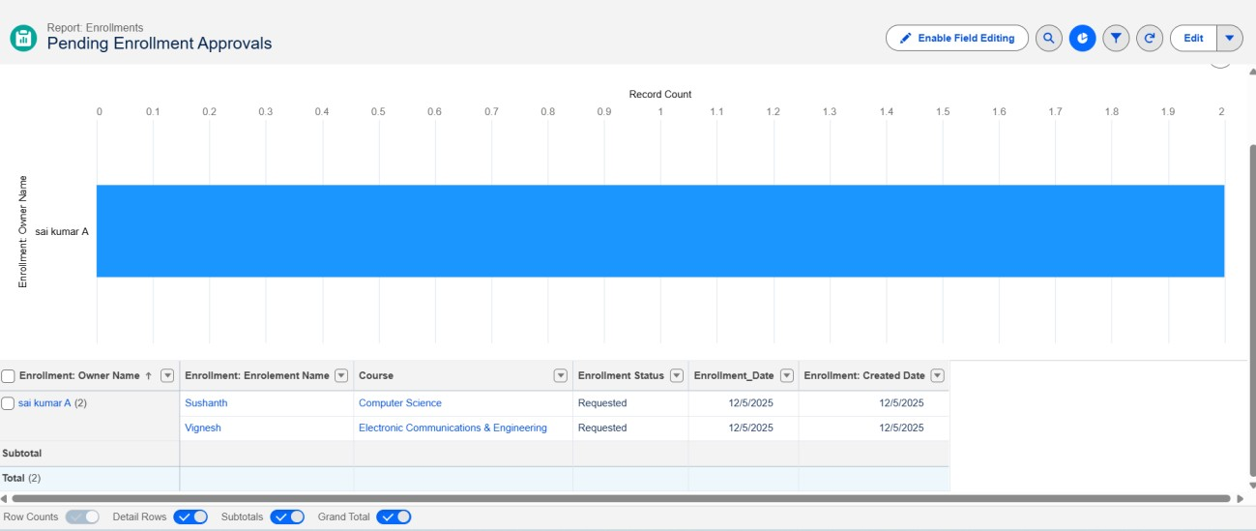
Activity 4: Create “Payment Collection by Course” Report
- Go to Reports → New Report and select the Enrollments report type.
- Apply the filter:
Payment_Status__c = "Paid".
- Group the report records by Course__r.Name.
- Summarize the Amount_Due__c field to display the total amount collected for each course.
- Add columns such as Student, Course, Registration Date, Payment Status, and Amount Due.
- Save the report as Payment Collection by Course.
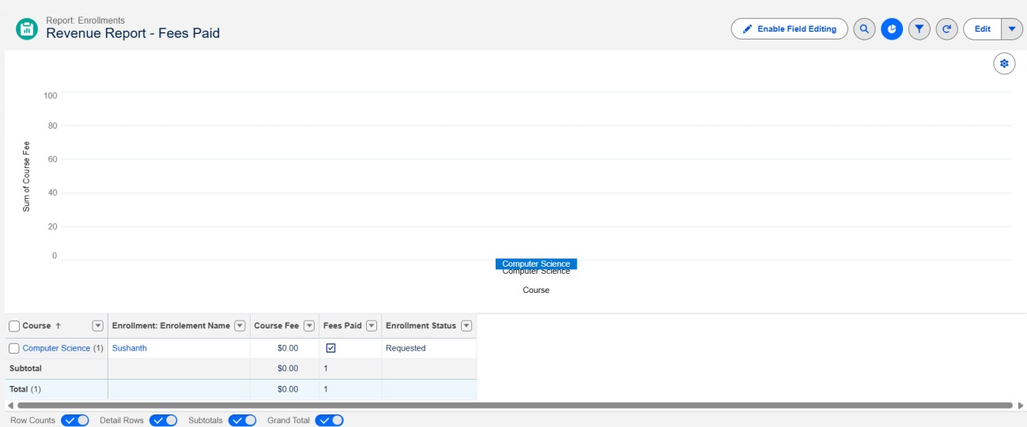
Milestone 12 – Dashboards
Activity 1: Create “Academic Registration Dashboard” Steps:
  - Go to Dashboards → click New Dashboard.
  - Name: Academic Registration Dashboard.
  - Enter a suitable description such as “Dashboard for monitoring course registrations, student participation, and registration status.”
  - Select the required Dashboard Folder and click Create. Add components:
  - Pie Chart → using Registrations by Department report.
  - Horizontal Bar Chart → using Course Registrations by Status report. ● Metric Component → using Payment Collection by Course report to display the total amount collected.
  - Table → using Unprocessed Course Registrations report.
  - Arrange the components on the dashboard canvas according to the required layout.
  - Click Save and review the dashboard to ensure that all components display the required academic information.

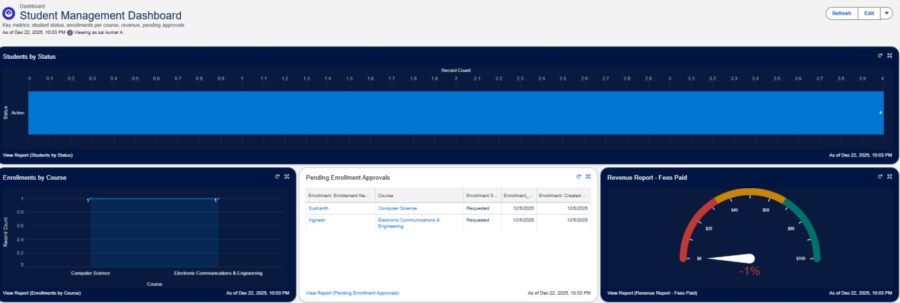

Milestone 13 – Security Setup
Activity 1: Configure Profiles
Profiles Required:
- System Administrator – Complete administrative access to the application.
- Academic Coordinator – Manage student, course, and registration records.
- Faculty Member – View relevant course and student registration information.
  - Go to Setup → Profiles and select an existing profile to Clone.
  - Enter the profile name: Academic Coordinator.
  - In Object Settings, configure the following permissions:
○ Enrollment__c: Read, Create, Edit.
○ Student__c: Read, Create, Edit.
○ Course__c: Read and Edit.
○ Instructor__c: Read.
4. Configure the required field-level permissions and click Save.
Repeat the configuration for the Faculty Member profile and provide only the access required for academic activities.

Activity 2: Create Permission Sets
- Go to Setup → Permission Sets → New.
- Create a permission set named Academic Record Access to provide additional access to selected SECMS objects.
- Create another permission set named Reporting Access for users who need additional permissions for creating and managing reports.
- Configure the required object and system permissions.
- Assign the permission sets to the appropriate users.

Activity 3: Configure Sharing & OWD Steps:
- Go to Setup → Sharing Settings.
- Configure the Organization-Wide Defaults according to the required access level:
○ Student__c: Private.
○ Course__c: Public Read Only.
○ Enrollment__c: Private.
○ Instructor__c: Public Read Only.
3. Click Save.
For users who need access to specific registration records, additional sharing rules or permissionbased access can be configured according to their role.

7. FUNCTIONAL & PERFORMANCE TESTING
The testing phase was carried out to confirm that the major modules of the Student Enrollment & Course Management System (SECMS) operate correctly.
Testing included the creation and modification of student, course, faculty, and registration records. Validation rules were tested using both valid and invalid data to confirm that incorrect entries were restricted.
The record types and page layouts were checked to ensure that the appropriate information was displayed for different registration scenarios. Flow automation was tested to verify automatic date updates, registration notifications, faculty assignment, and follow-up task creation.
The approval process was also tested by submitting registration records and checking the approval and rejection actions. Reports and dashboards were reviewed to confirm that registration statistics, department-wise data, and payment information were displayed correctly.
Screenshots of the important testing activities should be included in the documentation as evidence of successful system verification.

8. ADVANTAGES & DISADVANTAGES
Advantages
- Improved Data Organization
Student, course, faculty, and registration information can be maintained in a structured Salesforce environment.
- Reduced Manual Work
Flows and approval processes automate repetitive academic administration activities.
- Better Monitoring
Reports and dashboards provide a convenient way to monitor registration activities and academic information.
- Role-Based Access
Different users can receive permissions according to their responsibilities.
Disadvantages
- Platform-Based Operation
The application depends on the Salesforce platform and its available services.
- Configuration Complexity
Building objects, relationships, flows, permissions, and reports requires proper Salesforce knowledge.
- Customization Limitations
Some advanced requirements may require additional Salesforce configuration or development.

- Conclusion
The Student Enrollment & Course Management System (SECMS) provides a structured Salesforce-based environment for managing important academic activities. The system brings student profiles, course information, faculty details, and registration records into a connected application.
Salesforce features such as custom objects, lookup relationships, validation rules, record types, page layouts, flows, approval processes, reports, dashboards, and security settings help organize the complete registration workflow.
The implementation demonstrates how a cloud-based CRM platform can be adapted for academic administration by reducing repetitive tasks, improving record visibility, and supporting controlled access to information.

- FUTURE SCOPE
- Online Fee Payment Integration
The system can be connected with a secure payment service for handling course and registration payments.
- Student Login Portal
A dedicated student interface can allow students to view courses, submit registrations, and track their status.
- Automated Academic Notifications
SMS, email, or application notifications can be expanded for important registration and academic updates.
- Advanced Analytics
Additional dashboards can be developed to identify registration trends, course demand, and department-level statistics.
- Mobile Application
A mobile-friendly application can provide access to important registration services from smartphones and tablets.

11. APPENDIX
- Configuration Details: Salesforce objects, fields, relationships, flows, validation rules, and security settings.
- Testing Evidence: Screenshots of important configuration and testing activities.
- Sample Records: Demonstration records created in the Salesforce Developer environment.
- Reports & Dashboards: Final reports and dashboard configurations used for system monitoring.
- Project Demonstration: Salesforce Developer environment containing the implemented SECMS application.

Thank You

